PRESBYTERY OF SHEPPARDS AND LAPSLEY
TERMS OF CALL

Approved by COM 12/08/20 for recommendation to PSL

Three-way Contract
A pastoral call to a church requires the approval of the congregation calling, the minister being called, and the Presbytery (through its Commission on Ministry). Once established, change in the terms of call likewise requires the approval of all three parties.

Annual review by Session
“The Session shall review annually the minister’s terms of call and shall propose for congregational action (BO G-1.0501) such changes as the session deems appropriate, provided that they meet the Presbytery’s minimum requirements. (See BO G-2.0804) Any reduction in effective salary must receive approval of the Commission on Ministry before payments are changed and must also be approved by the Presbytery with the Annual Approval of Terms of Call. Bonuses and gifts paid by the church exceeding 20% of effective salary must receive prior approval by the presbytery.

Annual cost of living consideration
In keeping with the annual review, sessions are urged to consider both merit increases and annual cost of living adjustments, mindful that less than the COLA represents a reduction of salary in terms of buying power.

Minimum terms of call for full time ministers
of the Presbytery of Sheppards and Lapsley

“The terms of call shall always meet or exceed any minimum requirement of the presbytery in effect when the call is made.” (BO G-2.0804)

Effective salary
The effective salary is typically the sum of cash salary and housing allowance or the value of a manse. Please use the Effective Salary Worksheet on Page 6 to calculate Effective Salary. Effective Salary is used to calculate Board of Pension Dues.

Cash salary
Minimum salary is the amount that a starting pastor should receive and does not take into account the pastor’s education, experience, proficiency, abilities or particular needs.
Details of minimum cash salary are on page 5.

Board of Pensions dues
“The call shall include participation in the benefits plan of the Presbyterian Church (USA), including both pension and medical coverage” (BO G-2.0804). The current BOP dues are 37% of the total effective salary.

Housing allowance
In lieu of a manse, the call shall include a housing allowance sufficient to provide a home. To satisfy IRS requirements, any portion of the salary designated as housing allowance must be approved by the congregation prior to payment. To facilitate this requirement, sessions should take action on any proposed change in the housing allowance prior to the end of the tax year.

Social Security
The call shall include a reimbursement of at least 50% of the SECA obligation.

Professional expenses
While specific amounts may be part of the call, it is advantageous to the pastor to have this in a designated “Accountable Reimbursement Plan” whereby the minister is reimbursed for substantiated documented expenses (auto, travel, continuing education events, books, etc.). These expenses are thereby not included in reportable income for IRS purposes. A minimum allocated by the church should be $4000.

Moving expenses
The calling Church pays for or reimburses pastor for reasonable moving expenses incurred.

Continuing Education and Study Leave
Two weeks shall be allowed each year in the terms of call for continuing education or independent study provided it is used for that purpose. It is not to be regarded as additional vacation.

Vacation
The call shall include four weeks of vacation each year (initially prorated in the first year of employment based on the beginning of service).

Sick leave
For his or her own care and that of others, the pastor is not expected to work when sick. Illness lasting more than a week shall be considered by the Personnel Committee, and any recommendations referred to the Session for information and/or action.

Parental and Family Leave
Guidance on parental and family leave can be found in the following policy on the Presbytery web site: Presbytery of Sheppards and Lapsley Parental and Family Leave Recommendations for Ministers of Word and Sacrament, Commissioned Ruling Elders, Certified Christian Educators.

. Sabbatical
A Sabbatical Leave of at least three months after six years of service to an individual church is recommended and must be considered as part of the pastor’s annual review of terms of call Any congregation unable to implement a Sabbatical Leave plan within the guidelines of the Presbytery policy shall provide a written rationale to the COM along with the present terms of call.

Anti-racism Training
All Ministers of the Word and Sacrament who are serving as pastors of a congregation are required to participate in a training program organized by the Anti-racism Committee at least once every three years. Additional information may be found in the Presbytery of Sheppards and Lapsley Policy on Racism and Training Prepared by the Anti-Racism Committee.

Healthy Boundaries Training
Healthy boundaries training is required every three years for all minister members of the presbytery.

Other Concerns

Extra time away
Pastor’s time away beyond vacation and study leave is to be determined by agreement between the session and the minister.

Presbytery participation and relationship
Pastors are presbyters, and vow to “be active in government and discipline, serving in the councils of the church,” to “be a friend among … colleagues in ministry, working with them, subject to the ordering of God’s Word and Spirit.” (BO W-4.003i, W-4.003e)

Part Time Pastors
The salary of part time pastors working at least 20 hours per week is prorated accordingly. Vacation and study leave remain the same as for full time pastors. For Board of Pension dues for a part time installed pastor, consult the presbytery Stated Clerk.

Temporary Pastors and Pulpit Supply Recommendations

Temporary Pastors
Temporary pastors working less than 20 hours per week are not covered by the Board of Pensions, and are paid in accordance with hours worked. Those working at least 20 hours per week may be provided benefits through the Board of Pensions.

Pulpit Supply
Persons serving in a pulpit supply relationship are paid an honorarium of at least $150 per Sunday plus mileage at the current IRS rate. A Presbytery appointed Session Moderator should be paid $50 per stated meeting. Mileage at the current IRS rate should also be paid if the Moderator travels to the location for Session meeting only.

Termination

Procedure
“An installed pastoral relationship may be dissolved only by the presbytery. Whether the teaching elder, the congregation, or the presbytery initiates the proceedings for dissolution of the relationship, there shall always be a meeting of the congregation to consider the matter and to consent, or decline to consent to dissolution.” (BO G-2.09)

Severance provisions
When the congregation initiates the termination, the pastor, congregation and Presbytery will negotiate a severance agreement consisting of three to six months continuation of the terms of call in effect at the time of dissolution of the pastoral relationship. If the pastor begins a new call the severance pay may cease.

PCUSA Resources
The Board of Pensions provides the following resources at pensions.org
- Understanding Effective Salary
- Calculators for Effective Salary and Dues

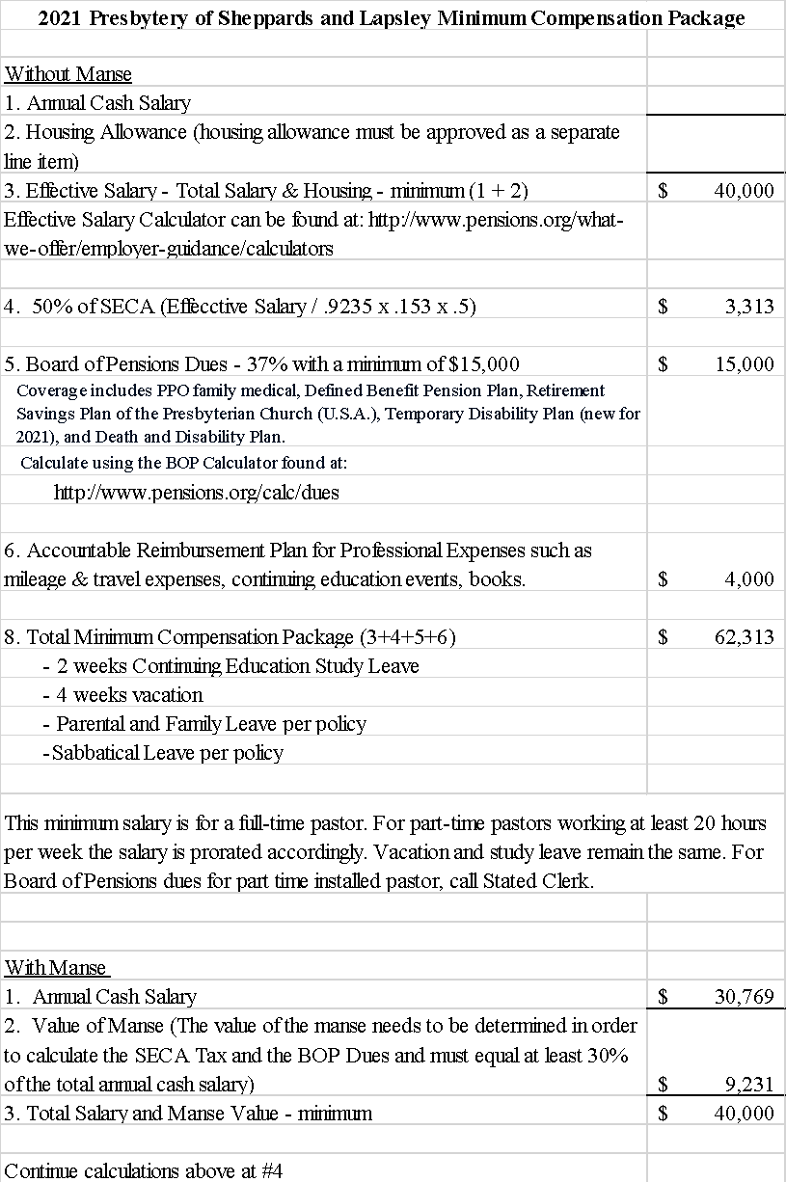
EFFECTIVE SALARY WORKSHEET
This worksheet is a guide to determining effective salary for Benefits Plan purposes. It may be helpful in submitting salary changes through Benefits Connect. The worksheet is for effective salary only and is not intended to provide Social Security or income tax advice. For income tax information, please refer to Internal Revenue Service publications or seek the advice of a competent tax adviser.

Compensation included in Effective Salary

1. | $ | Annual gross cash salary, not excluding employee contributions to 403(b)(9) plans, tax-sheltered annuity plans, and salary reduction contributions to FSAs, HRAs, and cafeteria plans.
2. | $ | Housing, utility, and furnishings allowances.
3. | $ | Employer contributions to 403(b)(9) plans, tax-sheltered annuity plans, and equity allowances.
4. | $ | Bonuses, overtime pay, unvouchered professional expense allowances, gifts from employer, and manse equity allowances (unless contributed to a qualified deferred compensation program). Include year-end or other bonuses, unvouchered allowances (e.g., expenses that are not paid through an accountable reimbursement plan), down payment grants for purchase of a home, savings from interest-free or interest-reduced loans (not loan principal), and gifts paid by the employer. (Gifts received directly from private donors or honoraria are not included.)
5. | $ | Any allowance provided to reimburse SECA tax obligations in excess of 50 percent of the minister’s SECA tax obligation.
6. | $ | Other allowances, including all forms of compensation not otherwise covered on Lines 1-5, such as medical deductible and medical expense reimbursement allowances not paid through a group benefit plan, and insurance premiums for additional insurance coverage provided for individual employees (not premiums for group plan coverage).
7. | $ | Manse amount (must be at least 30 percent of lines 1-6 for members residing in employer-provided housing).
8. | $ | Total effective salary (sum of lines 1-7). Dues are computed and benefits are determined based on this amount.

Ministers called by congregations are considered by the IRS to be “employees” for federal income tax purposes but “self-employed” for purposes of social security taxation, and are required to pay quarterly estimated Federal income taxes and SECA taxes. Hence ministers pay the full 15.3% for social security coverage. Since employed persons pay only one-half of that, the policy of Presbytery is to include a reimbursement by the church of half (7.65%) of the SECA tax in the terms of call.

