PRESBYTERIAN WOMEN BIRMINGHAM CLUSTER
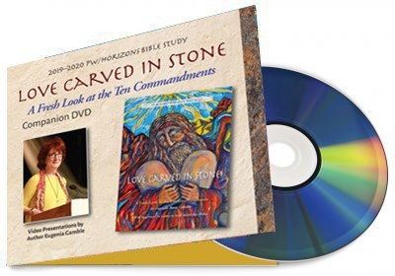
(This is a time of fellowship and worship for all P.C. Women whether you have active P.W. circles or not. Come for fellowship and worship with old friends and new.)
FALL GATHERING
SATURDAY, SEPTEMBER 14, 2019 COME TO THE HISTORIC WESTMINSTER P.C. 20 SIXTH AVE., S.W., BIRMINGHAM, AL 35211

9:00 – 10:00 A.M. REGISTRATION- CONTINENTAL BREAKFAST
SERVICE 10:15 – 11:15

STUDY OVERVIEW
BY
ELDER EVA CARTER AND MRS. TONEKA BELL.

QUESTIONS: Belinda Dickinson- 205 979 162- belindabjld@bellsouth.net
OR Charlotte Worsham-205 617 4467- c.worsham52@gmail.com
church phone 205 518 6292

