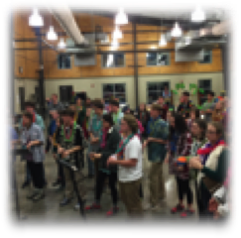
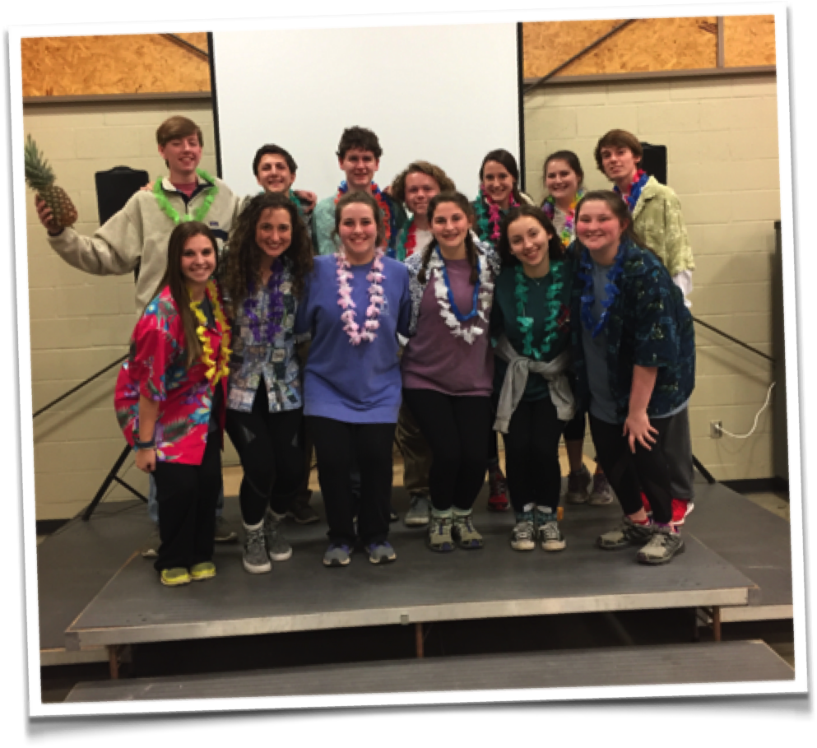
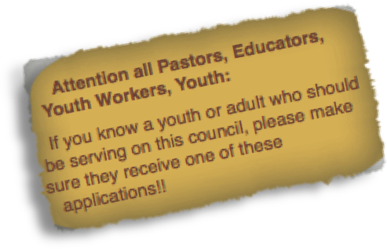

Would you like to be a part of:
Doing youth ministry at the Presbytery level?
Planning youth retreats?
Developing your leadership skills?
Making friends for life?
Growing spiritually?
Then apply today to be a member of the Sheppards & Lapsley Presbytery Youth Council! (Application form attached.)

For more info:
Betsy Murphy - Bets_southmin@bellsouth.net

Apply Now ~ SLPYC 2019 - 2020
Applications due April 30, 2019

SHEPPARDS & LAPSLEY PRESBYTERY YOUTH COUNCIL (SLPYC)
2019-2020 APPLICATION

NAME_________________________________________________________________GRADE NEXT FALL___________

ADDRESS____________________________________________________ CITY_____________________ZIP__________

EMAIL ____________________________________________HOME#___________________CELL#_________________

AGE________CHURCH _______________________________________________________________________________

**************************************************************************

How are you involved in your local congregation? Please include leadership roles you have held.

What Presbytery/Synod/General Assembly events have you attended?

What school and extracurricular activities will you be involved with during the coming year? How much time will you need to commit to these activities, and do you anticipate these commitments being a conflict with Youth Council activities?

Do you plan on being employed during the coming year, and will that conflict with Youth Council activities?

Is transportation to and from meetings and events a problem? How will you handle this?

PLEASE WRITE A BRIEF STATEMENT ON THE BACK OF THIS SHEET EXPLAINING WHY YOU WANT TO SERVE ON THE YOUTH COUNCIL AND WHAT GIFTS AND ABILITIES YOU FEEL YOU BRING TO THE COUNCIL. PLEASE ALSO READ THE QUALIFICATIONS AND EXPECTATIONS LISTED BELOW AND KNOW THAT BY APPLYING, YOU ARE AGREEING TO UPHOLD THESE TO THE BEST OF YOUR ABILITY.

QUALIFICATIONS/EXPECTATIONS OF YOUTH COUNCIL MEMBERS:
*Dedicated Christian member of a Presbyterian Church (USA)
*ACTIVE member of a local church youth group
*Will be a high school junior or senior in the fall of 2019
*Willing to put Youth Council responsibilities as a top priority in your schedule
*Willing to attend leadership/planning events in the summer
*Will attend and support with enthusiasm all Presbytery youth events (retreats, planning meetings)
*Willing to be a leader by example in your home youth group and Presbytery
*Recommendation from your Youth Leader/Minister
*Have read SLPYC selection criteria

I have read the above qualifications/expectations and agree to uphold these ideals and live them out to the best of my ability or agree to step down from SLPYC.

Signature________________________________________________________ Date_____________________________________

RETURN BY April 30, 2019 TO: Betsy Murphy
Presbytery of Sheppards & Lapsley
3603 Lorna Ridge Drive
Birmingham, AL 35216

For more information contact Catherine Goudreau (205) 790-1665 or cgoudreau@ipc-usa.org

Sheppards & Lapsley Presbytery Youth Council (SLPYC)
Youth Leader/Minister Recommendation

NAME OF APPLICANT

CHURCH

This form should be filled out by the Youth Leader/Minister of the applicant and returned to the address below. Please use the back of this form if you need more space.

Do you feel that your candidate would make a positive contribution to the Christian community of young people and adults that will participate in the programs and events planned and led by the SLPYC?

What gifts does this young person have that will enhance his/her serving on the SLPYC?

What weaknesses (if any) does this young person have that might hinder his/her serving on the SLPYC?

SIGNATURE OF Youth Leader/Minister

PRINTED NAME OF Youth Leader/Minister

PLEASE RETURN BY April 30, 2019

PLEASE RETURN COMPLETED FORMS DIRECTLY TO:
Betsy Murphy
Presbytery of Sheppards & Lapsley
3603 Lorna Ridge Drive
Birmingham, AL 35216
bets_southmin@bellsouth.net

