MINUTES
Presbytery of Sheppards and Lapsley
Synod of Living Waters
Presbyterian Church (U.S.A.)
Stated Meeting
February 24, 2017

GOD CALLS US TOGETHER

The Presbytery of Sheppards and Lapsley of the Synod of Living Waters of the Presbyterian Church (U.S.A.) met in the Stated Meeting on February 24, 2017 at Independent Presbyterian Church, Birmingham, Alabama.

Throughout these minutes, Teaching Elders are indicated by an asterisk (*).

The meeting was called to order at 2:00 p.m. by Moderator Jim Toomey, who opened the meeting with prayer.

The Moderator nominated Janet Bain, Church of the Covenant, to serve on Nominating and Representation, Class of 2017. This is the responsibility of the Moderator when there is a vacancy. The motion was approved unanimously.

The installation of 2017 Moderator, the Rev. J. Shannon Webster, and Vice Moderator, Ruling Elder, Jane Clayton, Montevallo Presbyterian, proceeded with the answering of the constitutional questions as detailed in the Book of Order. The presbytery, in return, pledged to honor, support and encourage each of them in their ministry. The Moderator’s cross and gavel were passed to Rev. Webster. The description of the cross appears in Appendix A.

Past Moderator Toomey was presented with a gift along with great thanks for his leadership over the past year.

ORGANIZATION
On advice of the Stated Clerk, a quorum was declared by the Moderator.

Adoption of the Docket
The docket was adopted as amended by common consent.

Seating of Corresponding Members
Jim Choomack, Presbytery of NE Georgia, Bill McConnell, General Assembly

Recognition of First Time Commissioners and Visitors

Nomination to Bills and Overtures Committee
The newly installed Moderator, Shannon Webster*, nominated Ruling Elder, Debbie Miller, First, Forestdale, and Teaching Elders, Jonathan Yarboro and Leeann Scarbrough to serve on Bills and Overtures Committee. The nomination was sustained.

Teaching Elders
Ministers Present (43) Excused (57) Absent (19)

Abernethy, Barrett P
Acton, Ben E
Adams, Nan P
Alexander, Frank HR E
Anderson, Mike A
Atkerson, Rick P
Bailey, Michael E
Bang, Yoo Chang A
Becker, Lindsay A
Bird, Shelaine A
Booth, Ben HR E
Brock, John A
Brooks, Richard , HR E
Brown, Taylor, HR E
Broyles, Vernon, HR E
Bruchey, Wayne HR E
Burgess, Sid, HR P
Carl, Bill P
Carleton, Rhon HR E
Carter, Clyde HR P
Casey, Lydia P
Chandler, Doris E
Chaney, Patsy HR P
Chinula, Donald A
Cho, Timothy A
Clark, Molly HR E
Clayton, Susan P
Clendenin, Monty HR E
Coker, Jeff HR E
Crutchfield, Bob HR E
Dantzler, Bill HR E
Davis, Becky HR E
Davis, Lant P
Dippenaer, Vic P
Duke, Mickey HR E
Durham, Charles HR P
Durham, Erica E
Edwards, Robert E
Ephraim, James A
Epting, Bobbie HR P
Feagin, Debbie P
Frease, Matthew E
Free, Zana P
Genau, Joe P
Goodlet James P
Goodrich, Cat E
Goodrich, Elizabeth P
Hanna, Richard P
Harmon, Dawson, HR P
Hay, Robert, HR P
Hayes, Jeff A
Hibbard, Norman HR E
Homer, John HR E
Hoop, Cathy P
Hurley, Ed P
Hurst, Clyce HR E
Inman, Robert F. HR E
Japhet, Catherine A
Jeong, Junmo A
Jones, Steve P
Kang, JD A
Kelso, Hugh, HR E
Kesler, Randy A
Kim, Sung Woong P
Kim, Young A
Laney, Susan, HR E
Lays, Brian P
McCarter, Neil HR E
McClendon, Bruce E
McClure, John A
McCormick, Mark P
McElrath, Pete HR E
McElveen, William HR E
McLaughlin, Wayne, HR E
McKean, Mac HR E
McLeod, James A
Moon, Hak Bae A
Mylalsingh, Emerson HR E
Newland, Terry P
Northen, Margaret HR E
O’Neill, Elizabeth E
Oh, Jyung, Ho A
Oliver, Catherine E
Patton, Finley HR E
Patton, Roger HR E
Pearce-Reed, Leanne P
Penson, Gozie HR E
Pope, Sam HR E
Porter, Mary HR P
Price, Sandra HR E
Pyburn, Richard, HR E
Rains, Tom HR E
Reed, Kathy P
Reed, Nick E
Rentz-Lane, Neely P
Scarbrough, Leeann E
Scrivner, Joe E
Seitz, Craig, HR E
Sellers, Lou Ann P
Shelton, Jack HR E
Sherwood, Paul P
Sims, Charles HR E
Slane, Joe, HR E
Speaker, Cary P
Stanford, Jim HR E
Stephens, Dan E
Stephens, Gerald HR E
Thompson, Ben HR E
Tingle, Terry, HR P
Truesdell, Jim A
Turner, Lucy P
Wade, Lindsey P
Waters, Dana HR E
Watson, Cody P
Webster, J. Shannon P
Wells, Jim, HR E
Wilkins, Jay P
Wills, Bill HR E
Winter, Rachel E
Winter, Tom HR P
Winton, Carlton, HR E
Yarboro, Jonathan P

Commission Ruling Elders with Vote
Present (6) Excused (0) Absent (3)

Arellano, Ben P
Bonner, Jeff P Harrison, John A
Dodson, Beverly P Sauser, Bill P
Eich, Sharon A. A Thomas, Roger P
Emerick, Robert A Veasey, Lin P

Executive Council Members/Presbytery Officers w/Vote
Present (7) Excused (1) Carter, Eva P Rick Reed E
Jane Clayton P Judy Rogers P
Frennea, Rick P Jean Russell P
Debbie Hamrick P Toomey, Jim P

Christian Educators, Presbyterian Women and Trustees Moderator w/Vote
Jenny Thagard P Bill Stribling P Dotty Lessley P

Elders
Number in parenthesis by church name indicates the number of commissioners authorized. “NR” indicates that the church did not have elder representation. There are seventy-six churches in Presbytery of Sheppards and Lapsley. Thirty-four Commissioners were present.

Alexander City First (1) NR
Annemanie Arlington (1) NR
Anniston Church of the Covenant (1) Sissy Bain
Anniston Church of the Good Shepherd (1) NR
Anniston First (1) Margaret Porter
Anniston First United (1) Debbie Miller
Anniston Korean (1) NR
Auburn First (2) NR
NR
Bessemer Good Hope (1) NR
Birmingham Bold Springs (1) NR
Birmingham Bryan Memorial (1) NR
Birmingham Center Point (1) NR
Birmingham Chapel in the Pines (1) NR
Birmingham Edgewood (1) Kevin Patton
Birmingham Fairfield Highlands (1) NR
Birmingham First (1) Mark Aldridge
Birmingham First United of Forestdale (1) Terri Jones
Birmingham Five Mile (1) NR
Birmingham Independent (5) Beverly Krannich
Eliza Warren
Larry Krannich
NR
NR
Birmingham Korean (1) Sam Chang
Birmingham Mountain Brook (1) NR
Birmingham Oakmont (1) Charles Pritchett
Birmingham Riverchase (1) NR
Birmingham Second (1) Hazel Ruth Bowden
Birmingham Shades Valley (1) Cindy Tarrant
Birmingham South Highland (2) Mark Garner
NR
Birmingham Southminster (1) Frank James
Birmingham Westminster (1) Lorino Hendricks
Cuba Cuba (1) NR
Camden New Trinity (1) NR
Carbon Hill First (1) NR
Dadeville First (1) NR
Dadeville Woods (1) NR
Eufaula First (1) NR
Gardendale Gardendale (1) Rodney Mewbourne
Goodwater First (1) NR
Green Pond Green Pond (1) NR
Jacksonville First (1) Carolyn Padgett
Lafayette Lebanon (1) NR
Leeds Leeds (1) Charles Gabbert
Livingston First (1) Molly Dorman
Magnolia Rock Springs (1) NR
Marion Junction Marion Junction (1) NR
McCalla Shepherd of the Valley (1) NR
Montevallo Montevallo (1) Jane Clayton
Montgomery Calvary Charles Ford
Montgomery Immanuel (1) NR
Montgomery Korean (1) NR
Montgomery Memorial (1) Kathy Sweezey
Montgomery Westminster (1) Bob Akers
Moundville Saint James (1) NR
Northport Bethel (1) Kathryn White
Odenville Odenville (1) NR
Opelika Korean NR
Oxford Dodson Memorial (1) NR
Phenix City First (1) NR
Piedmont First (1) NR
Plantersville Mount Pleasant (1) NR
Reform First (1) NR
Selma Northern Heights (1) NR
Selma Pisgah (1) NR
Selma Valley Creek (1) NR
Springville Springville (1) NR
Sylacauga First (1) Patsy Shuttlesworth
Talladega First (1) NR
Troy Williams Memorial (1) NR
Trussville Cahaba Springs (1) Carl Martin
Tuscaloosa Brown Memorial (1) Charles Nash
Tuscaloosa First (3) Tony Hubbard
Ellen Potts
Mike Henderson
Tuscaloosa Korean (1) Duke Park
Tuscaloosa Grace (1) Darryl Thornton
Tuskegee First (1) NR
Tuskegee Ramsay Memorial (1) NR
Tuskegee Institute Westminster (1) NR
Union Springs Union Springs (1) NR
Wetumpka First (1) Linda Williams

We were warmly welcomed by William Carl*, pastor of Independent.

Jenny Thagard, chair of the Main Event Committee, shared the events to be held tonight and tomorrow during the Main Event. Jenny noted that a representative from Presbyterian Publishing was here with a variety of books available for sale.

Executive Council Report – Lou Ann Sellers*
Recommendations for 2017:
- Recommend a Search Committee be formed for a General Presbyter. (Standing Rule 5.0104) If this action is approved today, the Nominating Committee will propose a Search Committee at the May 2017 meeting of presbytery.
- Recommend the Search Committee consist of 3 Teaching Elders and 2 Ruling Elders to include diversity in age, gender and geography. In accordance with the Book of Order and this presbytery, they shall not all be of the same race or ethnicity.
- Recommend the job description for General Presbyter, Standing Rule 5.0104 The items 1-3 were moved and approved unanimously.
Recommendations effective January 1, 2018:
- Two-Person Staffing Model to consist of the following positions:
a. General Presbyter
Salary $50,000.00*
Housing 25,000.00*
Medical and Dental 19,280.00*
Board of Pensions 12,341.00*
Continuing Education 1,000.00*
SECA Tax 5,738.00*
Increase in Travel Expense 10,600.00 (Increase from $5600.00 plus additional
$5000.00 listed on line item 500118 in budget as Travel TEP)
TOTAL PACKAGE $123,959.00
*Held at current value

b. Office Administrator/Assistant to the Stated Clerk
Salary $37,720.00
FICA 2,885.58**
Medical and Dental 12,780.00**
Board of Pensions 4,286.00**
TOTAL PACKAGE $57,671.58
**Held at current value

Total proposed presbytery salary and benefits beginning January 1, 2018 = $181,630.58

- Recommend Elder Frank James to Nominating Committee as Stated Clerk beginning January 1, 2018. Increase the expenses of the Stated Clerk's budget from $8,000.00 to $10,000.00.
- Recommend Volunteer Mission Coordinator also serve as Hunger Enabler effective, January 1, 2018 to include the $1000.00 stipend as compensation. Mrs. Linda Burrowes is currently serving in this position and her retirement on December 31, 2017 will leave a vacancy for this position.
The motion to approve items 1-3 was presented and approved unanimously.
Living River. In continuing to be a board with a breadth of leadership skills, the Living River Board asks for the presbytery’s approval to elect Drew Hamiter, First Tuscaloosa, to a three-year term on the board beginning January 1, 2017. The Living River Board and executive council approved changes to the Living River By-Laws defining the presbytery’s representation on the Living River Board. The impacted articles with changes are recommended for presbytery’s approval.
Drew Hamiter was approved for service on the Living River Board beginning January 1, 2017.

BYLAWS OF LIVING RIVER: A RETREAT ON THE CAHABA, INC.
ARTICLE III DIRECTORS
SECTION 2. TERM OF OFFICE, QUALIFICATION AND APPOINTMENT OF DIRECTORS
Directors shall be nominated by a committee to be known as the Governance Selection Committee. The said committee shall consist of the Chair of the Board, the Executive Presbyter of the Presbytery, the two persons designated by the Executive Council of the Presbytery to serve on the Board and three members of the Board selected by the Chair. The Governance Selection Committee shall take the following characteristics and considerations into account when selecting nominees, and the Board shall consider the same characteristics and considerations when electing Nonaffiliated Members: . . . . .
No less than two-thirds (2/3) of the members of the Board, including the Executive Presbyter of the Presbytery, and the two persons serving on Council, selected by the Executive Council of the Presbytery, must be composed of persons who belong to churches that are members of the Presbytery (“Affiliated Persons”). The remaining directors may be persons who are not members of such churches (“Nonaffiliated Persons”). The nominations of Affiliated Persons to be members of the Board shall be presented to the Executive Council of the Presbytery for approval and the Executive Council will then present the nominations to Presbytery for election and approval.
..... .
The Executive Presbyter of the Presbytery, and two persons nominated by the Executive Council of the Presbytery shall serve as members of the Board with all the rights and privileges accorded other members of the Board including the right to vote on matters coming before the Board for a vote. The Executive Presbyter shall serve while holding said office, and the persons selected by the Executive Council of the Presbytery shall serve three year terms. Such persons selected by the Executive Council shall be considered as Affiliated Persons for purposes of requiring approval by the Presbytery. Motion was approved unanimously.
Presbytery of Sheppards and Lapsley Child & Youth protection policy. In seeking to protect all of our children, General Assembly in 2014 moved to require all presbyteries to have a child and youth protection policy. Together with the larger church, the presbytery has worked to draft a policy. Our presbytery has also sought to use this policy to build awareness and advocacy for child protection issues. Many thanks to Lydia Casey*, who spear-headed the child protection policy team, together with Robert Hay*, Lin Veasey and Jay Wilkins* for their time and effort. Executive council recommends the attached policy for the presbytery’s approval. (see Appendix B) With a motion from Jay Wilkins, seconded, the motion was amended so that the reporting date was changed to January 1st of each year. The motion passed. The Child Protection Policy was adopted.

Treasurer’s Report – Jean Russell
(see Appendix C)

Equip, Nurture and Connect – James Goodlet*
James shared about this new committee that has been put in place replacing the old Nurture Division. The ENC encompasses three main aspects of presbytery life. Those are college ministry, youth and children’s ministries and small church ministry. Questions were raised about older adult ministry and James said that this area could be considered in the future,

College Ministry Task Group

Camp Scholarships – Patti Winter
There is opportunity for every child in the presbytery to attend camp at Living River through a scholarship program of the presbytery. The scholarships can be up to one half of the cost of camp for each child needing assistance. There is also a tiered pricing opportunity that is outlined on the Living River website.

Small Church Report – Appendix D

The offering collected today will be divided equally between CPM for candidates and a presbytery discretionary fund for pastoral care.

The body joined in singing, God, Whose Giving Knows No Ending followed by passing the peace of Christ with one another.

Transitional Presbyter Report – Jay Wilkins*
First, I give thanks to be able to report that our invitation to congregations last fall to make a pledge to the 2017 Mission budget of the Presbytery has borne fruit. As of February 6, 2017, we have had 20 congregations pledge $210,608.24 to the Mission budget. Pledges are still coming in!
What difference does your mission giving make? Your giving supports retreats for small church leaders, camp scholarships for children and youth at Living River. It makes possible Youth Council and “Main Event” leadership training. Mission giving provides support for those being called into ministry, and for ministers and congregations seeking to serve Christ and neighbors.
Last year, 26 of our congregations contributed $271, 983.94 to the Mission budget. If you have not already done so, your congregation may still participate in this fruitful opportunity; a pledge sheet follows this report,

Second, I give thanks for the risk you have taken to support the PneuMatrix work beginning to happen in eight of our congregations. The funding for this ministry was approved from the Development Grant Fund, a restricted fund “established to provide grants for New Church Development and for existing church development, growth, and vitality.”
The congregations participating are Cahaba Springs, Chapel in the Pines, Grace-Tuscaloosa, Montevallo, Mountain Brook, Shades Valley, Springville, and Westminster/Birmingham. The “adaptive change apprentices” learning to navigate challenges and change without easy answers are: Daniel Killilea, Catherine Mason, Lynda McLean, Kathryn Michael, Kevin Patton, Dot Riley, Leeann Scarbrough*, Lindsey Wade*, and Nan Adams*.
These are adventurers for the mission of God in our changing culture and congregations. Please thank them all, and keep them in your prayers. We are all being transformed as we follow where Christ leads!

Jay welcomed Bill McConnell from the Presbyterian Mission Agency. He is our first connection to missions in the PC(U.S.A.). Bill is a mission engagement advisor who brings greetings and thanks from Louisville. He gave thanks to this presbytery for the assistance given to the mission of the church. He thinks of himself as a conduit to and from the Mission Agency and offered his assistance in any way that is needed.

Commission on Preparation for Ministry – Joe Genau*
FOR INFORMATION:

INQUIRERS CHURCH INSTITUTION
Bennett Alldredge First, Tuscaloosa Princeton
Rachel VanKirk Mathews First, Tuscaloosa Columbia
Mary Sellers Shaw Independent, Birmingham Vanderbilt
Caitlin (Avery) Smith University, Tuscaloosa Louisville
Alexandra Stewart First, Tuscaloosa Columbia
Samuel Turpen Edgewood, Birmingham Columbia

CANDIDATES
Courtney Bowen IPC, Birmingham Louisville
Rebecca Mann Immanuel, Montgomery Graduate (Columbia)
Leigh Ann Min First, Birmingham Graduate (Columbia)

FOR ACTION:
- The commission recommends that Inquirer Rachel VanKirk Mathews of First Presbyterian, Tuscaloosa, be approved by Presbytery for Candidacy
(statements attached). (see Appendix E) Rachel shared about herself and spoke of her sense of call to ministry. At this moment she senses that God is calling her to ministry within a congregation hoping to be able to incorporate all of her skills. She shared of the involvement and influence of all four of her grandparents and of the faithful lives they have led. The examination was sustained and Rachel will be moved to candidacy status. Rachel responded to the constitutional questions and agreed to abide by the tenants of the Presbyterian Church, U.S.A. James Goodlet* and Kathy Wolf Reed* presented the charge to Rachel and asked God’s blessings upon her journey.

Commission on Ministry – Ben Arellano
1. COM approved the following Churches to continue supply relationships for 2017
a. Calvary requests permission to continue their relationship with Rev. Lisa Winston
b. Church of the Covenant requests permission to continue their relationship with CRE Lin Veasey
c. Church of the Good Shepherd requests permission to continue their relations with
Rev. Ed Sellers.
d. First Dadeville requests permission to continue their relationship with CRE Ben Arellano.
e. First Phenix City requests permission to continue their relationship with Rev. G. Taylor Brown.
f. First Piedmont requests permission to continue their relationship with Rev. Gary Black.
g. First-Reform requests permission to continue their relationship with Rev. Jerry Douglas, SS; and George McLaurine, temporary supply.
h. First United Anniston requests permission to continue their relationship with Rev. Carlos Woodard.
i. Five Mile requests permission to continue their relationship with CRE Sharon Eich.
j. Gardendale requests permission to continue their relationship with CRE Jeff Bonner.
k. Goodwater requests permission to continue their relationship with Rev. Pete McElrath for the first 3 Sundays of the month and Hugh Kelso on the 4th and 5th Sundays..
l. Green Pond requests permission to continue their relationship with CRE Bev Dodson.
m. Mount Pleasant requests permission to continue their relationship with Rev. Ira Blanchard.
n. Odenville requests permission to continue their relationship with Rev. James Elrod.
o. Pisgah requests permission to continue their relationship with Rev. Ira Blanchard.
p. Rockspring requests permission to their relationship with Rev. V. L. Hackworth, Jr.
q. Springville requests permission to continue their relationship with Rev. Tom Winter and
Rev. Debbie Feagin.
r. Valley Creek requests permission to continue their relationship with Rev. Cecil
Williamson.
s. Westminster-Birmingham requests permission to continue their relationship with Rev. Clyde Carter.
t. Woods requests permission to continue their relationship with CRE Ben Arellano.
u. Bethel requests permission to continue their relationship with Rev. Dr. Mark McCormick
v. Northern Heights requests permission to continue their relationship with Rev. Angela Brown
and Rev. Rugus King. A letter has been sent to the clerk asking for info on Rev. King.
w, Marion Junction requests permission to continue their relationship with Dr. George Wood
x. Westminster-Tuskegee requests permission to continue their relationship with Dr. Gregory Gray.
y. Goodwater requests permission to continue their relationship with The Rev. Pete McElrath
z. Second requests permission to continue their relationship with The Rev. Steve Jones
2. Received and approved CRE report from Dean of Training Bev Dodson (Appendix F).
3. The Presbytery has already approved the Administration Commission for Grace Presbyterian to set the Installation date and for the A/C to serve as the Commission. Installation date for Rev. Cathy Hoop is February 12, 2017. Commission: Teaching Elders: Ben Acton and Mark McCormick. Ruling Elders: Donna Winn (Brown Memorial), Claire Nichols (First-Tuscaloosa), Bill Stribling (South Highland) and Rush Watson (Grace), ex officio member of the Board of Trustees.
4. Dismiss Rev. Brian Copeland to Presbytery of Charlotte effective October 25, 2016.

ACTION ITEMS:

1. Interview and approve Rev. Betty Angelini as member-at-large in a validated ministry,
effective Feb. 22, 2017, with permission to celebrate the Sacrament of the Lord’s Supper, as
Executive Director for Living River. Statements are attached. (see Appendix G)
2. Interview and approve Rev. Patrick Harley as Campus Minister for UKirk-Birmingham. His
effective date is March 6, 2017. Effective salary is $50,000, BOP $18,693, Moving Expenses up to $5,000 (including breaking lease), Con Ed $750 and Travel $1,000. Total package $75,443. Four weeks vacation, 2 weeks study leave, 2 weeks parental leave and 3 months sabbatical leave after 6 years. Statements are attached. (see Appendix H)
3. Interview and approve Rev. Dongouk Shin for Korean-Birmingham. Effective date is March 1, 2017. Effective salary $45,320, BOP $16,541.80, Travel $1,000, Con Ed $1,000, Books, etc. $800. Total Package $64,661. Installation date is April 2, 2017 at 4:00 p.m. Commission consists of: Teaching Elders: Shannon Webster, Molly Clark and Jay Wilkins. Ruling Elders: Jane Clayton (Montevallo) and Paul Park (Korean-Birmingham). (see Appendix I)
4. Interview and approve Rev. Jim Choomack, if the way be clear, with Honorably Retired status. Statements are attached. (see Appendix J)

Each of the four were introduced to the body and asked to share a bit of personal information
about themselves as well as what they feel they bring to the presbytery. Among them they
shared that they bring healing, a listening ear, a sense of familiarity, enthusiasm, and hard work.

The examinations were sustained and the four were welcomed into the presbytery.

5. Approve retirement for Rev. Robert Hay effective January 31, 2017. Approved.
6. Memorial for Rev. Sherwood Taylor (see Appendix K)

Prayers were offered for all these by Susan Clayton*.

Trustees – Bill Stribling
Trinity
Motion: Upon the sale of Trinity Presbyterian Church, Birmingham property seventy-five percent (75%) of the net proceeds is to be allocated to the capital campaign for an adult cabin at Living River.
This motion does not prohibit the remaining 25% or any other portion being allocated to Living River when the property sells. Final allocation will be made by Presbytery when the sale occurs. The motion was approved.

Robinson Memorial
Motion: Trustees recommend distributing the proceeds of the sale of Robinson Memorial as follows:
Congo Partnership- $20,000
Presbyterian Children’s Home, Talladega- $20,000
CRE Educational expenses fund- $20,000
Presbytery Mission Coordinator - $12,700
Campus Ministry (acct 830400)- $20,000
TOTAL $92,700
The motion was approved.

Harper Chapel
For information: An offer to purchase the property for $5,000 was accepted by the Trustees under the provision of Presbytery standing rules allowing small property matters to be transacted without Presbytery approval. This sale will close in Jan-Feb 2017 and net about $3,000.
Insurance carriers
For information:
Insurance representatives are being invited to attend the August Presbytery meeting at Shades Valley in Birmingham. The three insurance companies approved by General Assembly have been invited to attend. This will be an opportunity for churches to compare rates and coverage or establish contact for the future.
Westminster Synod loan
For information: Westminster, Birmingham has applied for a loan from Synod that requires approval of Presbytery Trustees and the Executive Council. That approval was granted.

Nominating and Representation – Cathy Hoop*
Motion to approve Dr. Jim Davis, First-Talladega, to the Board of the Presbyterian Children’s Home. Dr. Davis was approved to serve.

Synod Report – Eva Carter and Neil McCarter*
(see Apprendix L)

Omnibus Motion and Stated Clerk’s Report – Tom Winter*
For the Omnibus Motion
- Approve the minutes of the November 10, 2016, presbytery meeting.
- Approve requests for absence for today’s meeting.
- Record the receipt of minutes of the Commission to install Paul Sherwood as Pastor of Oakmont Church, Birmingham.
- Approve dates and locations for the 2017 meetings of presbytery:
February 24, Independent Church, Birmingham
May 11, First Church, Auburn
August 17, Shades Valley, Birmingham
November 9, TBA
5. Dismiss the Administrative Commission for Grace Presbyterian with thanks.
The omnibus motion was approved.

For Information
- In accordance with presbytery’s Standing Rules, there is no imbalance between teaching and ruling elders.
- To record the review of Session minutes, without exception, of First, Carbon Hill, and First, Jacksonville, Memorial-Montgomery, Church of the Covenant and Mountain Brook.
- Training for new Clerks of Session will be held on Saturday, March 18, 10:00 a.m. to noon at the presbytery office.
- The following congregations did not present their 2015 minutes for review:

Arlington, Bryan Memorial, Calvary, Cuba, Dodson Memorial, Fairfield Highlands, First, Auburn, First United, Forestdale, Five Mile, Good Hope, Immanuel, Korean – Anniston, Korean –Auburn/Opelika, Korean – Birmingham, Korean – Montgomery, Korean – Tuscaloosa, Lebanon, Marion Junction, Mount Pleasant, New Trinity, Northern Heights, Oakmont, Odenville, Pisgah, Ramsay Memorial, Rock Springs, St. James, Shepherd of the Valley, Westminster, Birmingham, Westminster, Montgomery, Williams Memorial, and Woods.

Therefore, the Stated Clerk will develop plans for the review of 2015 and 2016 minutes for the above mentioned churches during 2017.

Clerks of Session are reminded to do your own checklist of items that need to be covered in your own minutes. Please bring to the review your checklist as well as your minutes, printed and signed.
5. Please check to see if your church’s statistics have been entered. If they have not, please contact Linda Burrowes at the Presbytery Office by February 28, 2017.

For all the Saints who from their labors rest
The names of those who have joined the great cloud of witnesses during 2016 were read by Tom Winter*.
Presbytery of Sheppards and Lapsley
2016 Necrology

Ministers
Rev. Sam Andreasen – February 8
Rev. Harold Knox – May 27
Rev. Edward “Bill” Mullins – August 18
Rev. Sherwood Taylor – December 2

Ruling Elders
Brown Memorial
Burkles Davis, Sr. -- June 30, 2016
Cahaba Springs
Ron Prevatt – January 28
Paul Watkins – September 19
Bobbie Jordan – December 24
Chapel-in-the-Pines
Lois Albright – June 26
Edgewood
Lois North – February 4
Kenny Smith – September 18
First United Presbyterian – Anniston
Annie Ruth Jones Hall – May 30
First United Presbyterian Church of Forestdale
Robbie Allen (former recording clerk of Presbytery) – October 3
Marilyn Powe – December 8
First – Alexander City
Sam Mason – February 19
Joanne Baird – June 7
Rita Kennedy – December 12
First – Birmingham
Wallace Brockman – April 21
Wallace McRoy – October 8
First – Dadeville
Harry D. Cleveland – January 21
First – Eufaula
Barbara Jean McDonald Lee – April 20
First – Jacksonville
Glenn D. Hester – September 12
Peggy-Lynn Prescott – February 18
First – Sylacauga
Dot Bolton – May 28
Virginia Hassett – July 23
First – Talladega
James Earl Howard – April 27, 2015
First – Wetumpka
Homer Lawrence – March 22
Doris Sanders – August 21
Five Mile
Suellen Snapp – November 12
Gardendale
Burt Holloway – December 29
Goodwater
James Bruce Johnson – March 11
Independent
Joel Ruffner Hillhouse – April 15
James A. Todd, Jr. – May 5
Charles Allen Long – June 1
Susan Barrett – October 1
Leeds
Jarome Brymer – February 6
Mountain Brook
Beth Lankford – November 4
Oakmont
Stacie Harris – April 7
Pisgah
John Ross Long – April 21
Riverchase
Bob McConnell – April 4
Martha Dorrance – September 24
Springville
Jo Carole Dawkins – November 27
Southminster
Brian Warren Wheeler – April 4
Robert E. Cox – June 20
Leland Bardwell Arnold – August 12
Samford Chalker – October 17
Catherine Horton – December 5
Union Springs
Bill Salter – August 5

University
Mabel Francis Caldwell – June 4
Westminster – Montgomery
Margaret Smith Collins – December 28

The body joined together in singing a Hymn of Promise.

Good News from Our Churches
Several churches shared good news of the things happening in their areas. Recognition was given to those churches that contributed to Cents-ability by the Hunger Action Enabler, Linda Burrowes.

Montreat Report – Richard DuBose
Good news was shared of all that is happening at Montreat. About 30,000 visitors will be visiting Montreat throughout the year. There is continued innovation in programming as well as fiscal responsibility in order to see that the ministry is sustainable. It is our heritage as Presbyterians that binds us together and Montreat is an integral part of that cord.

Living River – Pat Goodman
A new Executive Director has just been approved, which is one of our greatest joys to share this year. There are brochures of all that’s happening available as well as promotional fliers for summer staff. Pat invited everyone to stop by the Living River table for lots of information. A video for this years camp was shown.

Living Waters – Terry Newland*
Information was shared describing our continued involvement in Living Waters for the World, a program that began in 1993. In the early days the thought and plan was to build water treatment systems that could purify contaminated drinking water. In 2004, the focus changed from building systems to teaching people how to build the systems and to replicate that process. As water systems are built in a community, these can teach others to assist in building clean water systems in other communities. Teams of 3-4 can attend training at Camp Hopewell in Oxford, MS, where they will learn to build the systems and learn how to teach others to build the systems. As of 2016, 837 systems have been installed and maintained throughout the world.

Presbyterian Home for Children – Jacque Cordele
Jacque Cordele, Director of Resource and Development, shared her story of working each day with children, young adults and families taking a mess and turning it into a message. She highlighted a program of intensive in-home services called Family Bridges. The Home is operating at full capacity and new programming is being developed to meet the needs that continue to arise. Work is being done on construction of additional housing. She expressed her deep thanks for the continued help from the churches in the presbytery.

The meeting was closed with prayers offered by Vice Moderator Clayton followed by the benediction given by Moderator Webster at 5:20pm.

The meeting was adjourned to dinner and worship with the Rev. Dr. Tom Long.

The next meeting of the presbytery will be on May 11th, at First Presbyterian, Auburn.

Appendix A

THE MODERATOR’S CROSS
Presbytery of Sheppards and Lapsley
By: Dean Vandegrift

In 1988 the Presbytery of Sheppards and Lapsley was formed and elected its first moderator.

Frank Vandegrift, a member of First Presbyterian Church, Auburn, Alabama and a veteran of many years of Presbyterian mission work in the Congo, had a cross fashioned by local artist Howard Wadsworth. It was given to be worn about the neck by each successive moderator of the presbytery and includes a three-inch copper cross and blue trading beads.

The copper cross was cut from a larger cross used at one time by the Congolese in the Kasai Region of Zaire for currency. One such cross which dates from the time when William Henry Sheppard, Lucy Gantt Sheppard, and Samuel Norvell Lapsley established the Congo mission, hangs in our presbytery office. Hot molten metal was poured into sand molds to form the crosses.

The blue trading beads, known as mutunda, came from Bibanga, also in Zaire. Some of these beads were sent to the University of Johannesburg (Witwatersrand University) and the following reply was given by Dr. Van-Riet-Lowe, Head of the Department of Archeology: “The chain of mutunda beads sent…from Bibanga are typical Venetian dark blue annulars which were used by the Arabs as trade goods down the East coast of Africa during the centuries until comparatively recently. The specimens sent me, however, are so worn and old that they may well be medieval. Similar types are common in Zimbabwe, ruins of Southern Rhodesia and Northern Transvaal. We have specimens of these beads from Uganda, Kenya, Nyssaland, and the Rhodesiss and elsewhere, and your donation forms a valuable link with the Congo.”

The Moderator’s Cross symbolizes our presbytery’s commitment to mission, especially our mission past, present, and future in the Congo region. We are reminded that William Sheppard and Samuel Lapsley, from whom our presbytery got its name, both had strong ties to churches and institutions within the bounds of this presbytery and were the first Presbyterian missionaries to carry the Gospel message to what is now the Democratic Republic of Congo.

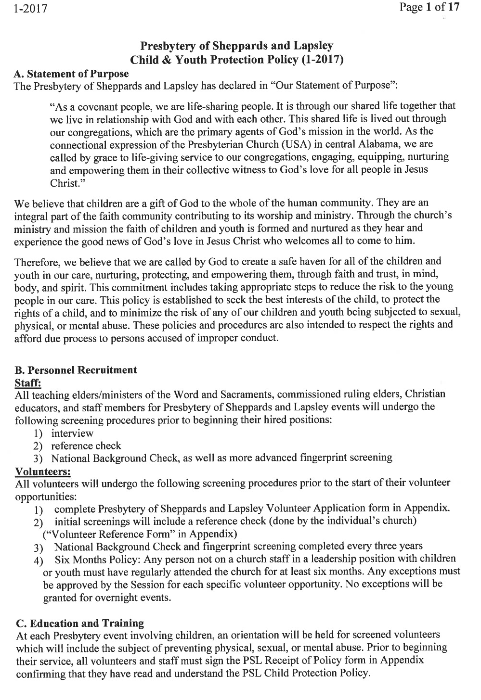
Appendix B
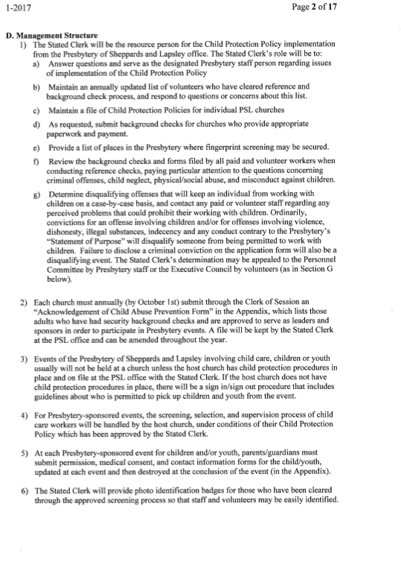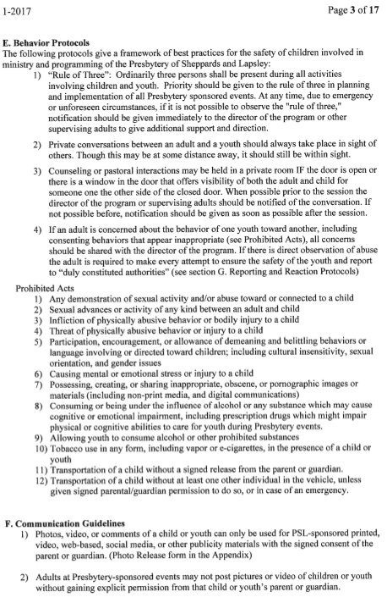
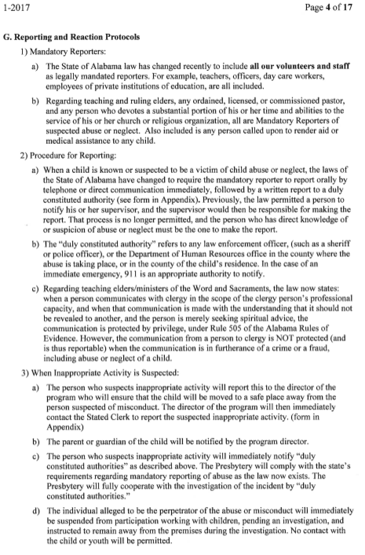
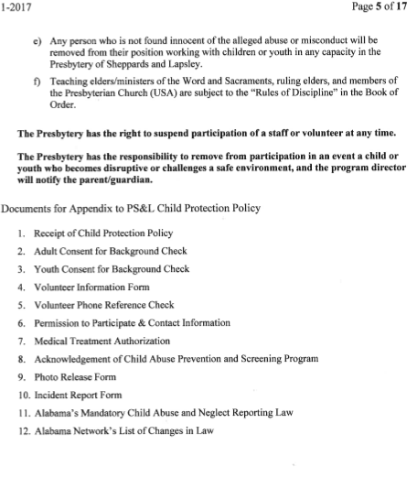

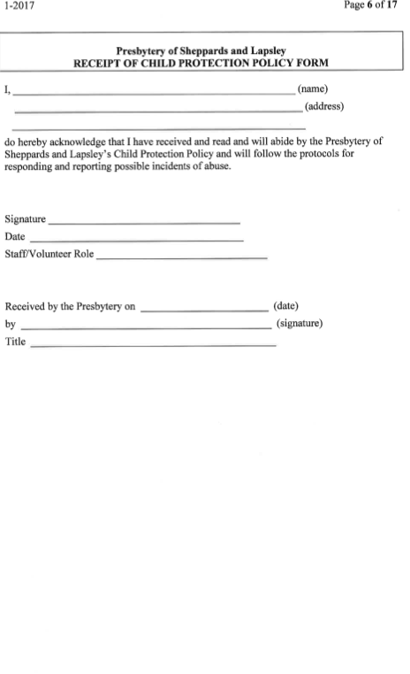
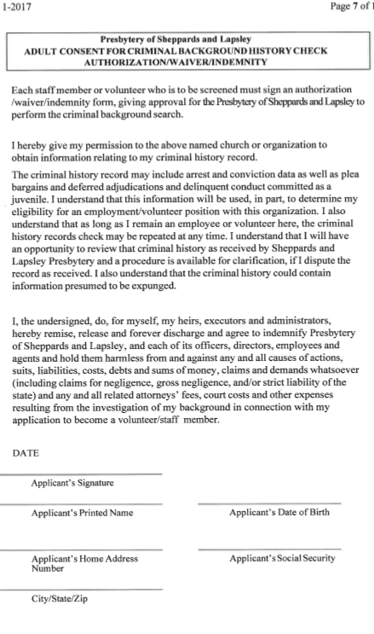
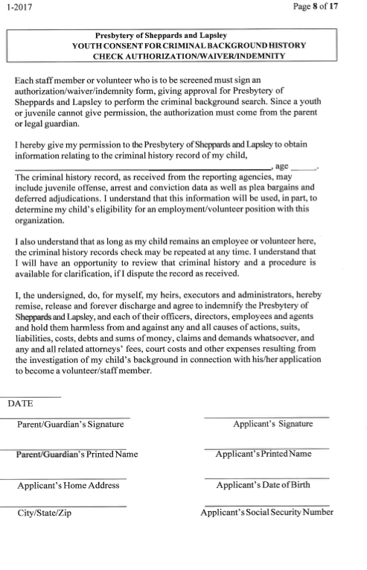

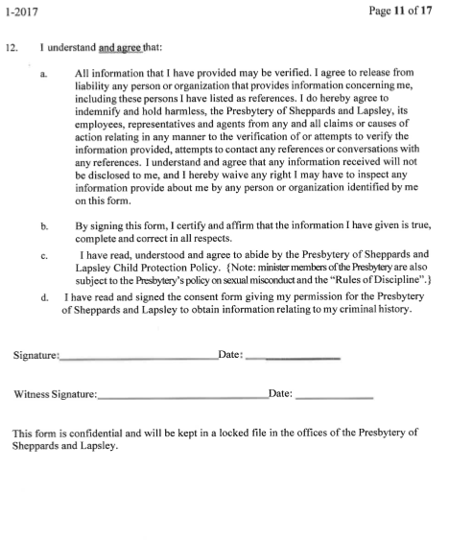

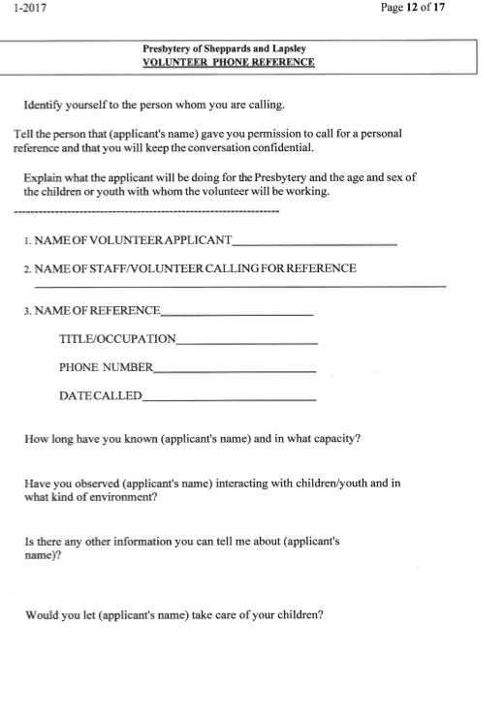
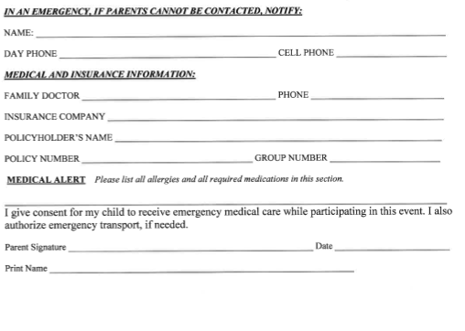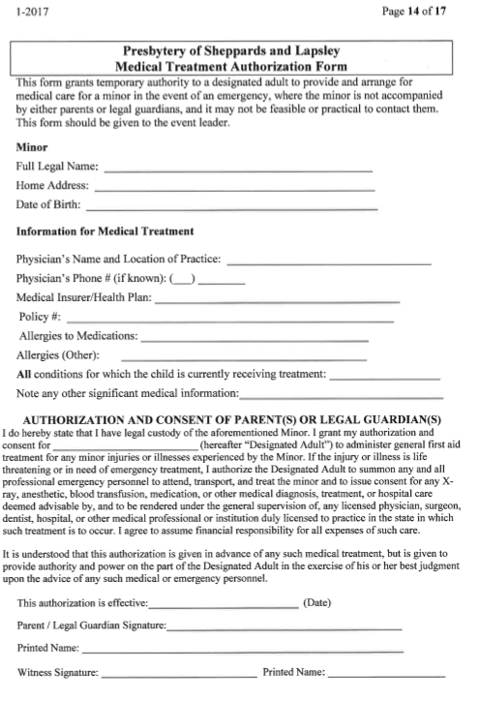
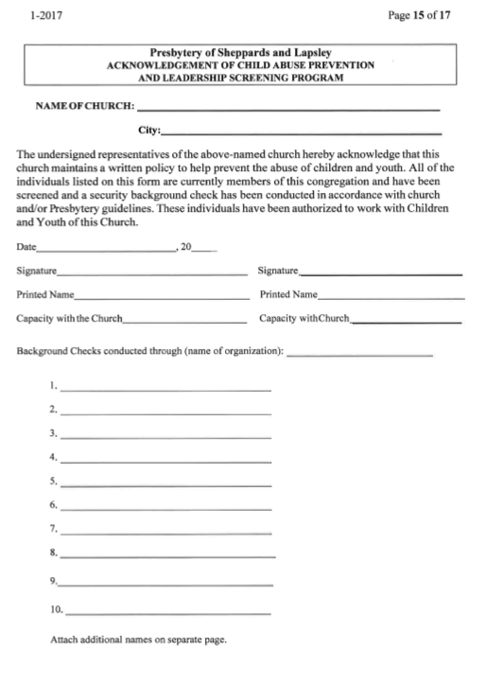
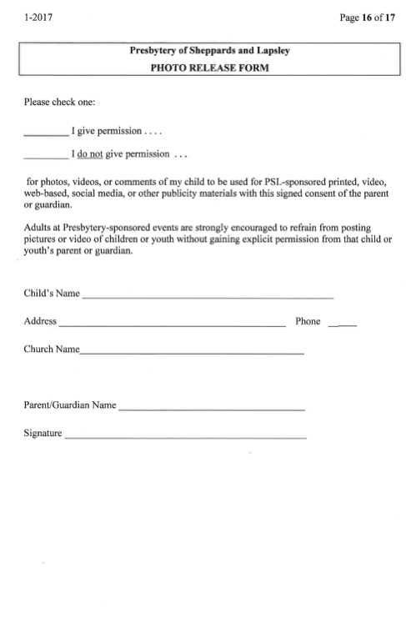
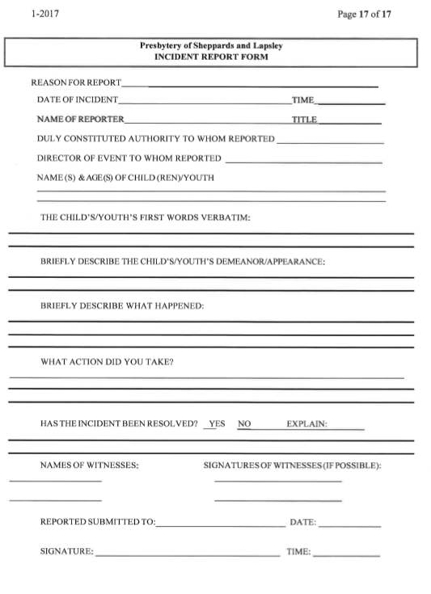

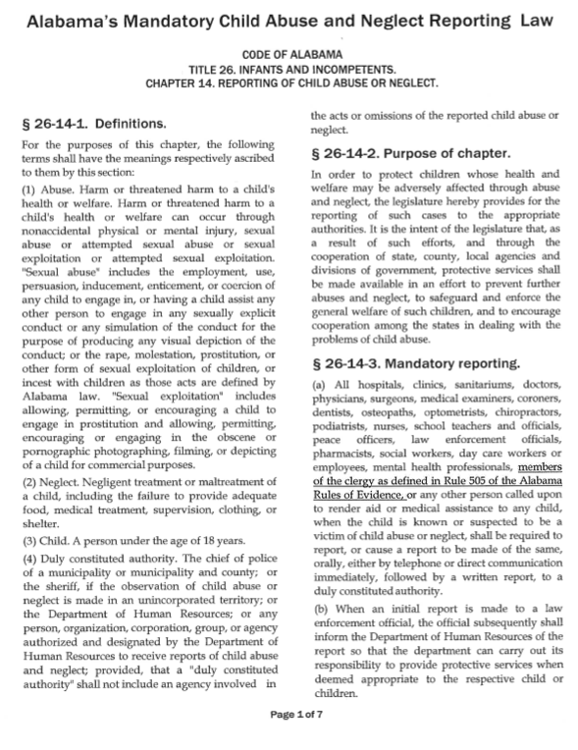

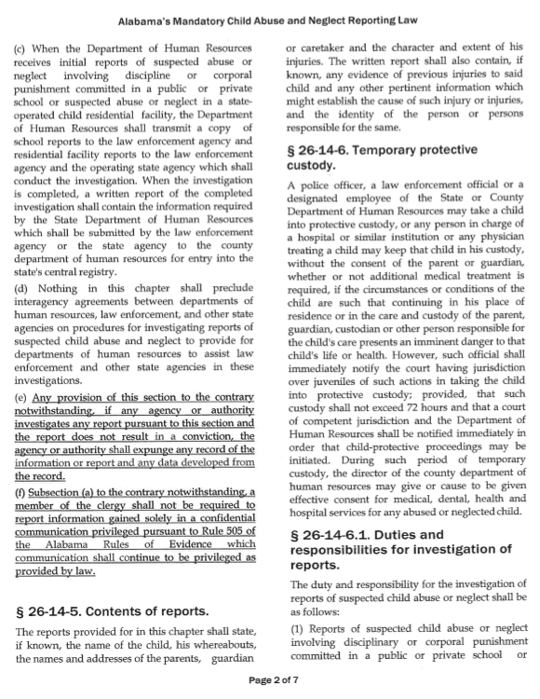

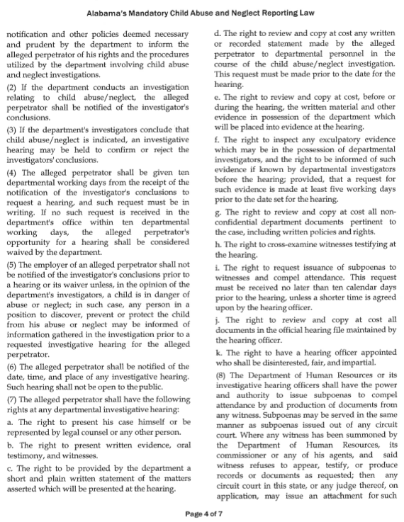

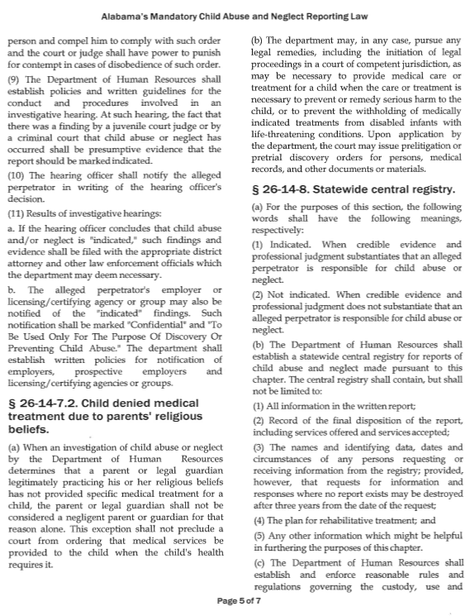

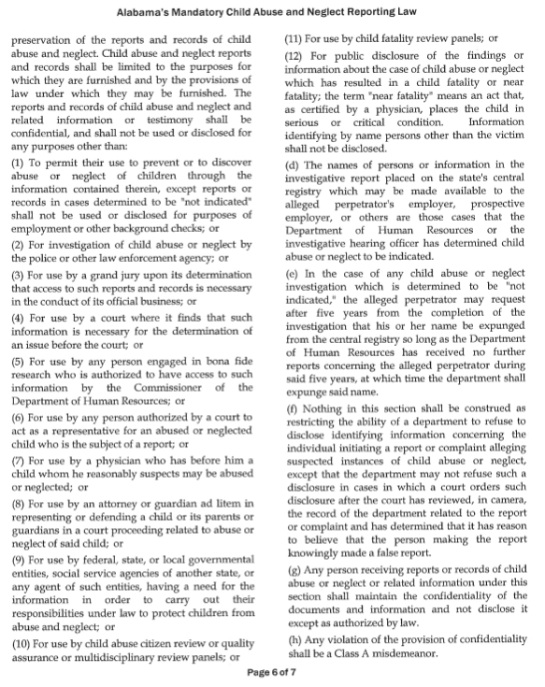

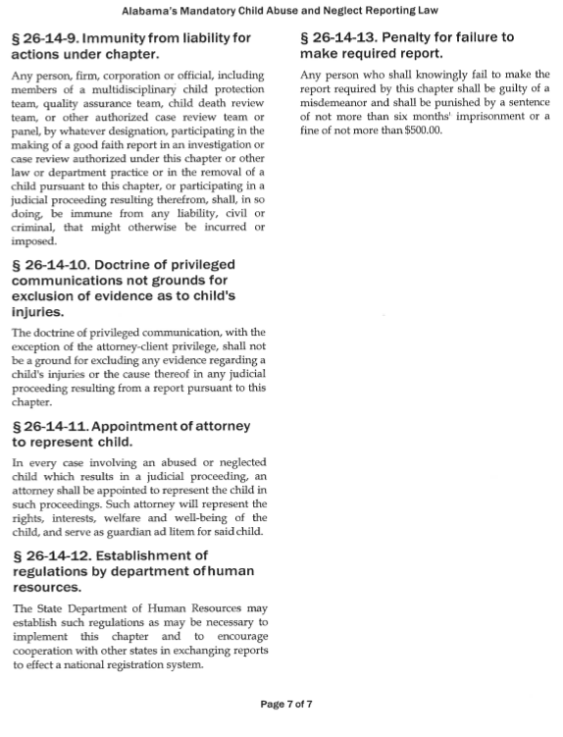

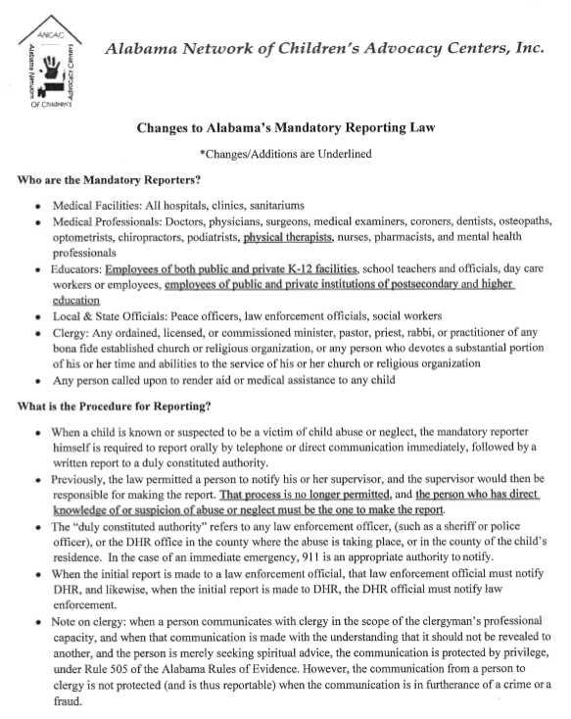

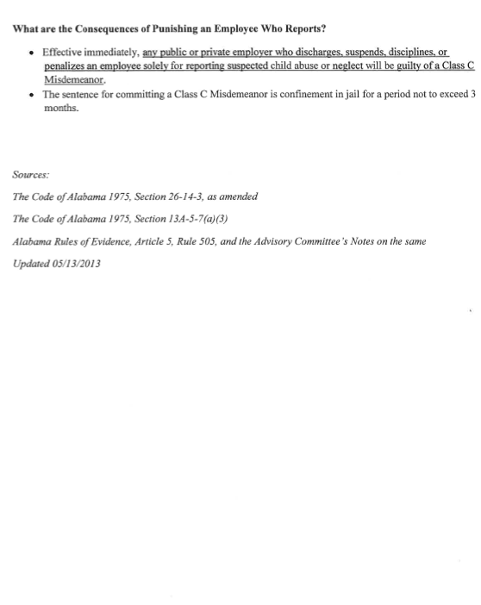

Appendix C

Treasurer’s Report

PSL Financials
January – December 2016

RECAP 2016/2017

2016 2016 2017
Actual Annual Budget Annual Budget

Revenues Total $519,767.00 $509,749.00 $477,327.00

Expenses Total $648,518.00 $662,161.00 $555,814.00

Shortfalls -$128,751.00 -$152,412.00 -$78,487.00

Appendix D

SMALL CHURCH TASK FORCE REPORT TO
PRESBYTERY OF SHEPPARDS AND LAPSLEY
FEBRUARY 24, 2017

On December 10, 2016, the third session in PROJECT RENOVATION led by the team of Paul H. Grier and Robert Hay, Jr., from the Presbyterian Foundation, occurred at Riverchase Presbyterian Church. This session focused on the buildings and property of small churches. Buildings and property can be both an asset and a liability. Building as assets of smaller membership congregations can be characterized as beautiful and historical in architecture, meaningful in remembrance of vital ministry and mission which have emanated from the buildings, but also are often very large in size. Buildings can be and often are liabilities in that maintenance of them and property often consumes much, if not a majority, of a congregation’s financial resources due to several factors: decreased membership and other social realities which are part of current culture and location. Mr. Grier and Mr. Hay were most helpful in offering resources and ideas as to how the membership of small churches can take advantage of their assets to accomplish their mission and ministry where they are.

The fourth and last session in this series of seminars for leaders of small churches will occur on April 1, 2017. Please place this date on your calendars and make your plans to attend. Event will occur at Riverchase Church.

On Saturday, January 28, 2017, at Living River, the Task Force sponsored the rescheduled church officer training event for leaders and pastors of smaller membership churches in the Presbytery. Approximately 40-50 persons attended. The four-hour event, which included lunch, was divided into four segments. The first one focused on the Biblical texts for Presbyterian polity and the vows and duties elders affirm for ordination/installation. Neil McCarter was the presenter for this segment.

The second segment dealt with one of the documents in the Book of Confessions: The Westminster Shorter Catechism. Presenter Jeff Bonner asked participants to read through twelve questions from the Catechism which he had listed on a handout. Participants were to choose two questions for which they were to read the Biblical citations which support the question. Then the participants were to discuss these questions: Are the Scriptures helpful? Do they defend the doctrine? Can you think of other Scripture passages which support the doctrine? Is the doctrine expressed in the question an “essential tenet”?

Barrett Abernethy led the group in discussion of several matters related to the Book of Order. First, he offered an overview of the Amendments to the Constitution on which the Presbytery as a will voted at its meeting in May. He also emphasized the mandate that each governing body was to have a child protection policy in place. Another matter which he had the group to consider is the “Southern Option” as it relates to the trust clause regarding church property.

The concluding part of the event was the opportunity for sessions to conduct their stated meetings.

The next church officer training event for leaders and pastors will occur in January, 2018.

Appendix E

Rachel Mathews
Statement of Faith
I believe in a Triune God who is the perfect communion of God the Father, God the Son, and God the Spirit. I believe in the incarnation of the Triune God as Jesus Christ whose birth, life, ministry, death, and resurrection are the primary revelatory acts of God. It is through Jesus Christ that God has revealed God’s creative and salvific power, God’s spirit, and God’s love. I believe in the merciful, liberative message and ministry of Jesus Christ who proclaimed the reign of God. I believe in the union of the human and divine natures of Jesus that allowed him to both eat with the outcasts and heal the sick, to both suffer on the cross and rise from the dead. I believe in God, the creator of the universe, by whom all things and people were made good. I believe in the Holy Spirit, the Spirit of God and of Jesus Christ, who spoke life into creation, wisdom into the prophets, and who speaks life and wisdom into us and our communities today.
I believe the earliest Christians gathered in response to the liberating, transformative power of faith in the Triune God as revealed through Jesus Christ. Like the earliest Christians, I believe generations of Christians past and Christians today are empowered to continually reimagine their tradition by the canonical Scripture which is, “the means of grace through which God’s Word is ever and anew received in the Christian community.” I believe in the priesthood of all believers. I believe every Christian is called to the same calling of faithful living as disciples of Jesus Christ: generosity to the poor, mercy for the outcasts, care for creation. I believe that this life is made possible through the mystery of baptism which imitates Jesus’ dying and rising as we die to ourselves and this world and rise as disciples of Christ. Finally, I believe it is God’s everlastingly new and patient grace demonstrated by the Lord’s supper, a meal that is always waiting, that makes discipleship possible despite our humanity.

Rachel Matthews
Faith Journey
I grew up in a small, Alabama town in which the entirety of my family lived. I spent every weekend at one grandparent’s house and would see the other set almost as often. Between my four grandparents, three different versions of Christianity were represented: Catholic, Presbyterian, and Baptist. Therefore, I saw very different, faithful relationships with God from an early age. My family moved only a few times, but in each new place, once we started to look for a church home, my parents were more interested in their connection with the pastoral staff and congregation than the denominational affiliation of the church. So, also from an early age, I learned to value community and relationships over politics and polity. Throughout my years before college I would be a member of a PC(USA), Baptist, Methodist, and Assemblies of God congregation. In each congregation, I would be challenged and encouraged in new, different ways, and make new, lasting relationships with inspiring, faithful Christians.
During my time at the University of Alabama, I was so blessed to call First Presbyterian and Ukirk UA my home. These congregations helped me grow deeper spiritually and discover my love for service and ministry. Once I was sure about my call to seminary, my husband and I began our time at Columbia Theological Seminary. In the last two years, we have gotten married, moved away from home, and been exposed to so much. At CTS, we have made relationships with many people different from ourselves, have come to understand many new perspectives, and have learned to engage community life and politics. My theological education so far has been life-changing and freeing. I am now committed to lifting up the marginalized, caring for God’s creation, and seeking and remaining open to the movement of the Spirit. I am hopeful to do all of this work in community with my family, friends, and congregation, creatively and collaboratively in the name of Jesus Christ.
Appendix F

Summary of CRE Reports for 2016

1. Banyon Allison – Completed CRE studies with Dubuque Theological Seminary. Commissioned by Presbytery at the August Stated Meeting with permission to supply preach and administer the Sacrament of Communion with prior permission from the COM Moderator or the Transitional Presbyter. Preached several times at First Presbyterian Jacksonville, Church of the Good Shepherd in Anniston and Leeds Presbyterian.
2. Ben Arellano – Commissioned to First Presbyterian Dadeville and Woods Presbyterian in Jackson Gap. Filled the pulpit on a weekly basis for both churches. Preached at Holy Week Service for First Church, represented the church at the local National Day of Prayer observance and represented the Church at the local food distribution ministry, Fishes and Loaves. Moderated Session for both churches. Continued in a relationship with the Dadeville Ministerial Association.
Officiated at a Wedding at Woods Church; prepared the Woods weekly bulletin, and provided a booklet of the entire Order of Worship, including sermon text for folks with hearing impairments. Officiated monthly communion at John Knox Manor in Montgomery, which is a ministry of home church, Memorial Presbyterian. Moderated the Presbytery COM and the Montgomery Westminster Administrative Commission. Attended the Presbytery continuing education for CRE’s in August; attended the Presbyterian Older Adult Ministries Conference in Richmond, Virginia in October and participated in the October two-day seminar, Talking Politics at Columbia Seminary.
3. Jeff Bonner – Commissioned to Gardendale Presbyterian Church. Fills the pulpit each Sunday; twice during the year, filled the pulpit at Bold Springs at 9:00 AM and at Gardendale at 11:00 A.M. Moderated the session and officiated at the Sacrament of Communion. Church focus is on five mission projects: Presbyterian Manor, Firehouse Shelter, Presbyterian Home for Children, First Light and Taiwan Missionary Rev. Dr. Jonathan Seitz. Extensive pastoral and personal reading focused on two parts in 2016, before and after death of son. Before the death, the readings were spiritual, business books with application for ministry, a Peter Marshal book and a book about the life of Brother Bryan of Birmingham. Several grief books dominated the reading after the son’s death. Attended the Presbytery sponsored CRE training in August.
4. Beverly Dodson – Commissioned to Green Pond Presbyterian Church in Bibb County. Prepared bulletins and led worship and/or Bible Study every Sunday in 2016; moderated quarterly session meetings and annual congregational meeting. Led three community fellowship events; special worship celebrating 190 years of ministry. Conducted one funeral; worked with local attorneys, session and Cemetery Trustees to finalize a Perpetual Cemetery Trust and investment in Presbyterian Foundation. Continued participation in home Church, Oakmont Presbyterian during 2016: attended Wednesday programs; taught PW monthly bible lessons September through May; Celebration Chair for Oakmont’s 50th Anniversary. Active in Presbytery entire year serving on Council and Trustees and as Dean of CRE program. Arranged and attended the Presbytery CRE training in August; attended the two-day PW Conference; daily readings and self-study.
5. Robert Emerick – Commissioned to Riverchase Presbyterian. Filed Pulpit, moderated session and provided other pastoral duties including his first baptism as a CRE. Pastored a family through a long illness and eventual death and conducted the funeral. Rev. Lydia Casey married Robert and Katie during a Riverchase worship service. Welcomed two new families into membership for the first growth in three years. Hosted three Presbytery Project Regeneration luncheons; successfully conducted a $40,000 capital campaign to fund renovation of the fellowship hall and sanctuary, as well as exterior repairs; continued mission support to First Light, SafeHouse of Shelby County, Sunday Suppers at South Highland, Presbyterian Home for Children and Living River. Participated in the Presbytery CRE continuing education event in August.
6. Sharon Eich – Commissioned to Five Mile Presbyterian Church –Weekly worship services; once a month luncheons, biannual hymn sing in old sanctuary, pastoral care as needed, moderated session, officiated communion, conducted funerals. Five-Mile joined with Gardendale church on three occasions for a potluck luncheon following worship. Celebrated 175 years of ministry. Sad occasion for her was the death of Pastor Emeritus, Harold Knox. He was both her friend and mentor encouraging her and helping her in her ministry at Five Mile. Attended the August continuing education class sponsored by the Presbytery.
7. John Harrison – Commissioned to Fairfield Highlands conducting weekly worship and celebrating communion several times in 2106. Moderated Session.
Attended the August continuing education class provided by Presbytery.
8. Ernie Haynes – Commissioned to Bold Springs Presbyterian. Provided weekly worship with special services on Maundy Thursday and Christmas Eve; celebrated communion the second Sunday of each month; Home Communion; moderated session and three congregational meetings. Easter Egg Hunt weekend before Easter. Received four new members in 2016. Led Wednesday evening Faith Studies. Officiated Communion first Sundays each month at home church, Centerpoint Presbyterian. Filled pulpit at Leeds Presbyterian three times; conducted one funeral; attended Presbytery meetings. Attended the annual Presbytery CRE continuing education class. Some personal readings included: What Every Christian needs to know about the Jewishness of Jesus, The Case for Christ and Mere Christianity.
9. Cal Holt – Not commissioned to a particular congregation. Fills pulpits as requested as available. In 2016, this was at First Livingston. Active at Home Church, First Tuscaloosa including: Chaired PNC for 26 months; Personnel Committee, Youth Committee, High School Sunday School teacher; worship leader. Five- year member of Presbytery CPM. Continuing education: Self Study various resources; daily bible study; preparation for teaching Sunday School; listened to over 100 sermons and visited several churches as PNC Chair.
10. Marilyn Jackson – Not Commissioned to a particular congregation. (Has had serious illness and surgery in 2016). Supply preached at Gardendale and Five Mile; Somewhat active in Emmaus and Kairos Outside communities; Active in home church, Edgewood Presbyterian as occasional lectionary reader; sings in Choir. Continued education: attended a three-day event at Blessed Trinity Shrine Retreat in Holy Trinity, Alabama. Self-study through extensive reading.
11. Gay M. Lake, Jr. – Not commissioned to a particular congregation. Filled pulpit at Gardendale one Sunday in 2016. Active in home church, First Tuscaloosa where serving on the active session, the finance committee and the endowment committee; chaperoned a youth mission trip. Presently serving on the Synod Permanent Judicial Council. An active Gideon. Participated in the annual Presbytery sponsored continuing education event in August.
12. William “Bill” Sauser, Jr. – Commissioned to Union Springs Presbyterian where he is the longest serving pastor in the 163- year history of the church. Led worship 45 times in 2016 including a special Maundy Thursday Service, a Christmas Eve Candle Light Service and an Easter Sunday Service at the Moorer Lake House in Macon County. Moderated bi-monthly session meetings and several congregational meetings; installed elders; hosted the 160th Mayor’s Prayer breakfast in August. Conducted funeral services for two church leaders. Pastoral care through letters, notes, telephone calls, emails, home and hospital visits. Church continued its ministry to transients in 2016 with meals, lodging, transportation; provided financial support to several local charities in Bullock County and the larger community including the food bank, prison ministry, Gideon’s, Presbyterian Home for Children; hosts 12-Step program and community organizations on a weekly basis. Attended the Presbytery sponsored continuing education class in August.
13. Roger Thomas – Commissioned to Dodson Memorial Presbyterian. Conducted worship three Sundays a month; moderated session, make home and hospital visits as needed, other pastoral duties as needed. Participate at home church, First Birmingham attending men’s breakfast and worship second Sunday of each month. Participated in the Presbytery CRE continuing education event in August; did an independent study on small church congregations and on the book of Deuteronomy. Continue to assist at no charge individuals in Birmingham and Oxford with Social Security questions and filings. Monetary offering divided between First Church Birmingham and Dodson Memorial.
14. Lin Veasey – Commissioned to Church of the Covenant for 25 hours a week. Conducted worship approximately 46 Sundays in 2016; provided visitation and general pastoral duties; welcomed six confirmands and six adult members; Service at home church, First Jacksonville, included moderating the Session, visitation and rogramming. Served on Presbytery Executive Council for the 5th year where I am liaison and board member to Living River; participated in the recognition of Stillman College in March. Attended the Congo Mission Conference celebration of 125 year of mission in partnership with Montreat in September.

Appendix G

Rev. Betty Angelini Statement/Faith Journey
Christian spiritual formation, the path that the journey of faith takes is not merely about the stops along the way but what is learned from those places of engagement. The following highlights not only those important occasions, turns or choices but, also the significance of those events. This is certainly not a complete journey map for it is in hindsight that one grows to appreciate the significance. I believe this gives you a starting point in getting to know who I am and who God has created me and called me to be. I look forward to getting to know you as well as our participation together in ministry in the Presbytery of Sheppards and Lapsley and Living River and how that partnership will transform us all.

Faith Journey of Rev. Betty L. Angelini | COM of Presbytery of Sheppards and Lapsley | Jan. 1, 2017
EVENT | INFORMATION | FORMATION
Baptism | By my father, Minster of Word and Sacrament with family surrounding | Identity of Child of God sealed
Piano Playing by Sunday School Teacher | Vague memory of singing song “Peace That Passes All Understanding” | Inclusion in family of God and continuing to develop trust that is basis of faith
Camp in 3rd grade | Began to realize that my faith is mine and not just my family’s faith | The power of the Holy Spirit in outdoor ministry
Confirmation | Confirming my faith as my own and able to approach the table for nourishment. Led by my father | Ongoing spiritual nourishment and continuing my own faith journey
Crestview | Worked at summer camp for 3 summers and beginning to realize God’s call in my life | The power of Holy Spirit in community  Ecclesiastes 4:9-12
College | Back and forth with God | Holy Spirit working through college family to keep me near.
Marriage and moving | Developing own family as moved from Pittsburgh to Chicago to Washington DC to Pittsburgh and now to Birmingham | Essential portion of moving was becoming member of a church.  My husband became member in Pgh so that our own children could have sense of family importance with church
Baptism of Children | Son Tony by my Father  Son Nick with my Mom as Ruling Elder | Traditions and Rituals of faith continue in family/We are all God’s children
Death of Father | Killed by Drunk Driver while doing ministry | Time to draw nearer to Jesus particularly during resulting depression
Logos Children and Youth Program Development | Collaborated with Associate Pastor to plan and implement after school program | Functioning as church leader in moving family church to medium size programmatic Church-Power of prayer
Faith Journey of Rev. Betty L. Angelini | COM of Presbytery of Sheppards and Lapsley | Dec. 29, 2016
Mission Trip to Mexico and God’s call | Last night of trip heard God calling to more formalized ministry (thought parish nursing focus) | Develop need for listening to Holy Spirit and not running from that call
Seminary | Pittsburgh Theological Seminary | Having faith to take risk
Crestfield-2004 | Became Executive Director | Importance of community in call process
Ordination to Teaching Elder | At Crestfield in outdoor chapel | Power of Outdoor ministry through Holy Spirit
Minister of Word and Sacrament | Preaching frequently for empty pulpits and preceding over the table | Living into identity of Preaching the Word and administering sacraments, particularly communion
Pilgrimages Iona | Practical Portion of Doctor of Ministry work at Columbia Theological Seminary | Time to rest, slow down, listen and understand beginning of restlessness
Pilgrimage Taize | Time to develop and imagine about young adult Christian Community | Continued time to rest, slow down, listen and understand ongoing restlessness
God’s call to Living River | Venturing into unknown | Deepening reliance on triune God and community
Completion of DMin | Graduation May 2018 focus on Christian Spirituality with final project on the effect of a specified curriculum on the  spiritual formation of young adults living in a residential community | Hope springs eternal

Appendix H

Rev. Patrick Harley's Narrative of Faith
On one hand, I embody a person for whom the institutional PC(USA) church has worked. My story looks like one of many success stories within this tradition. I'm just another individual who grew up in the upper-middle class, white church and who enthusiastically filled his resume with Presbyterian buzzwords like "Montreat" and "Triennium." I speak the tribal language of acronyms like YAV and YAD and COM and PNC and GA and MIF (We need to revisit that last one...). I move my body to the sounds of half-decent pop songs in what we call energizers all while drinking out of a bumper-sticker-covered Nalgene and wearing Chacos. I went through the Presby Checklist of Youth Group, Presbytery Youth Council, Campus Ministry, Montreat Summer Staff and Planning Teams, a YAV Year, Columbia Theological Seminary, and a first Call. I'm one blue and red PC(USA) logo tattoo away from being a potential poster- child for this denomination.
On the other hand, this tribal institution, while nurturing me and being the cradle of my spirituality, has not encompassed the entirety of my faith journey. What my PIF does not reveal are the many profound moments that have strengthened and ripped-apart my faith. I have comforted a mourning family in the Pediatric ICU, and I have cried into my mother's shoulder in the kitchen, terrified that I may not believe in God. In these, I have found that faith, in all of its many definitions, is more than just being involved in church activities.
For most of my early life, though, I thought that's what faith was - being active in a church. And, therefore, the opposite of faith was, obviously, not being active in a church. But then my understanding grew.
In college, during my YAV year, and in the early years of seminary, I thought faith was an acceptance of theological paradigms, essentially affirming doctrine. That meant that the opposite of faith was doubt. This caused many struggles for me, given that my faith story was now no longer being defined by my church involvement but by my intellect. As time has gone on, neither of these understandings of faith have held up.
Over the past few years, I've become increasingly aware that being active in church and accepting theological doctrine are not worth much as measurements of "being faithful." As I've worked through the day to day of vocational ministry and continue to work and wrestle and fall in love with Scripture, I'm now in a place where I find that the opposite of faith is not leaving church or doubt, but fear. As we, people of faith, are encountered with difficult decisions, difficult tasks, and dare I say difficult people, it is our call to listen to the Advent Angels and "Do not fear." I have found that my own efforts to follow Jesus and become a Disciple, it hasn't been doubt or a weak resume that's stood in the way. It's been fear. When I do, though, dig deep through prayer and contemplation, I have been able to eclipse the fear with faith, a faith that holds both a hope in a God that never gives up on us and the courage to act. Faith has become, for me, a paradigm and a practice. It has grown into a way of seeking to understand with my mind, feel with my heart, and act with my life.

Rev. Patrick Harley’s Statement of Faith
I believe in God, the Creator of awe-inspiring Creation the Mother (Isaiah 66:13) and Father (Mark 14:36) to all people, God's people. I believe in God, the unchanging source of all, an untamable God of love and grace.
I believe and trust in and seek to follow Jesus of Nazareth, the Christ, the Word made flesh (John 1). In Jesus, I see a God who turns the value system of our world upside down, a God who's love is as intimate as the manger and as expansive as the universe and its stars. The life of Jesus teaches and challenges me, helping me to value the dignity of every human being. The suffering and death of Jesus shows me that God has suffered beside us. The resurrection of Jesus ignites my hope that a world filled with violence and brokenness, deception and death, will not have the final say. God can and will redeem all of creation through love.
I believe in the Holy Spirit, God's Living Spirit, what the Hebrew people often called Ruach. This Spirit sustains us, surprises us, enables us to serve, and even sometimes works in spite of us. I believe in God's Spirit, always pulsing, beating, through all of creation, which garnishes the heavens (Job 26), is ever-present offering refuge (Psalm 139), and is the energy who causes dry, dead bones to stand and to have purpose and to live (Ezekiel 37). I believe in the Spirit, the Ruach, who gives life as she flows through our veins and in and out of our nostrils. She is also the breeze dancing through the autumn leaves and the gentle blue sky as she surrounds us.
I believe in the Trinity, the Triune God of faith, hope, and love, the three persons: God the Creator and Parent; the Christ, the Teacher and Redeemer; and the ever-active and never-predictable Living Spirit. This Triune God works and dances in a harmonious balance, revealing to God's people that we, too, should live in relationship and seek reconciliation as we are created in God's Image.
I believe in the sacredness, holiness, and life-giving power of the Bible. I believe that in Scripture, which God has inspired, humanity finds truth and inspiration and finds a gift in the ancient wisdom from the past as well as commentary on the present. We see ourselves in the stories of those who have sought God long before us. God’s Spirit guides our communal interpretation and wrestling with the Word as we seek to be guided by Jesus Christ as revealed to us in Holy Scripture.
I believe in the Church Universal, the Worshipping Body that together works to faithfully witness to the Gospel of Jesus Christ and to deeply love God and Neighbor.
I believe that the Church is imperfect yet still loved deeply by God. We catch glimpses of God’s stubborn love that refuses to give up on us in the Sacraments of Baptism and Communion. In Baptism, we celebrate God’s claim upon us. In the water, we are reminded of God’s grace that is poured upon us and our call to offer that same grace to others in our baptismal vows. In Baptism, we joyfully celebrate God's covenant with
Creation and our covenant and with members of our faith community and the Church Universal.
I believe that the Table of Communion is a holy moment, a glimpse of what God’s reign can look like here on earth. It’s at the Table of Christ that I’ve seen individuals gathered by God's Spirit who society says have no business being together. God's Table is always larger than our own comfort. At the Table I see glimpses of how God prefers to work - not in halls of power or skyscrapers, but small, in the hearts and minds and souls of all people, seeking a gathering place to be welcomed and renewed, challenged and sent out. God’s Ruach dances through us and our communities in the mysteries of the Sacraments and it’s in the Church that we have the honor and privilege of celebrating this Good News.

Appendix I
Faith Journey Statement
My father was a pastor. As I grew up in a family of Christianity, church became a crucial part of my life. This has become a great foundation for my pastoral life. Out of all my youth memories, I especially enjoyed my religious lifestyle and studies in high school. In high school, I met Pastor Hoonjoo Park and Pastor Gilsu Jung, who served as chaplains. Meeting with the pastors was the most impressive and touching encounter among all of my childhood experiences. One of the two pastors who were chaplains, studied in Japan, taught me literature and history, and provided me with various perspectives. The other pastor studied in the US. These two pastors preached to me about the human values, bible stories, their studies, better attitude towards life, diligence, initiative, and the ability to overcome the fear I might have had during my adolescence. My father’s pastoral life, his belief in Christianity, and his teachings influenced me to apply to a theological university.
Even though I was in the Korean front-line working in the cease fire line during my military service, I did my best believing in God’s delivery. Although I was only a soldier who had just graduated from a theological university, I had many opportunities to reach out to other soldiers. For example, I preached and taught them the Bible. I believe God gave such environment and the opportunity. A year before my required military service was over, with the help of other soldiers, we constructed a church in the military base. Since there wasn’t a chaplain in the army, I led a sermon in the newly constructed church of about 150 soldiers and officers. My military life was a course of theology. I returned to school after being released from the army. I could concentrate in theology on a deeper level. I studied the Old Testament in particular with an eager desire to learn. I was also interested in the historic Jesus and the Church of Paul. The meaningful lessons of the professors at the University of Theology enforced my passion for serving God.
2. The process of ministry and God’s grace gained during the process
Throughout my attendance at the Theological College, I served as an educational missionary for 2 years at Dongbu Church located at Yeoksam-dong, Seoul. As soon as I finished graduate school, I went down to Gumi-si, which was located on the country side. There, I began to serve at Gumi Church which emphasized heavily on church ministries. During my service, I was ordained as a pastor. Not very long after that, I went looking for an independent ministry. I began serving as the Pastor at Murim Church which was located at Namdam, Gyeongnam, Namhae Island. I served as the Pastor in the village of farming and fishing for 11 years. Through this ministry, I had the opportunity to experience the hardships of serving in a farming village. During the second half of the ministry, I shared the joys of helping the church grow together with the church members, as well as the people outside of the church. The ministry activities there was much like the work of servant of the Lord in Galilee. After this, God led me to experience at a bigger part of the World.
I resigned from Murim Church and began to study abroad at Emporia State University, located in Kansas. I am convinced this experience was God’s will to open up a new perspective in my ministry. During the difficult life of studying abroad, I met generous people who provided me with a house and a car. Others aided me to pay for my tuition. They were like the figures of Elijah. After 18 months, several followers of God in Daegu requested me to serve as the pastor with the desire to pioneer a new church. I accepted their request and immediately came back to Korea and served there for 10 years. The church originally started off with 7 people in the September of 2002. From that point on until my resignation, the church grew to about 130 adults and 50 youths. The experience and the grace I received from God is that He is always with and within me, so it is possible to escape from any fear. My greatest pride at Daegu, though, was the fact that approximately 60 church members were newly baptized.

Personal Statement of Faith
Dongouk Shin I believe that God is almighty. God is Almighty. He created all things and He runs it. And he loves his creatures [Genesis 1:01 / John 3:16]. God loves the world and his creation. But
God sent the only-begotten Son for the salvation of the world broken by our sin.
I believe that Jesus Christ the Savior of my life. I must confess that He is the Savior of all creation. Jesus died on the cross for the redemption of sinful life. He died on the cross and became buried again in three days. He was resurrected. Then he promised ascension show will
come back.
I believe in the Trinity, who is God, creating the heavens and the earth and sending Jesus
Christ, his only Son, to save us by believing in His death. God sent the Holy Spirit not to let his children be orphans. The Holy Spirit give us life, and he gave his life to protect us.
I recognize and accept the Bible as the Word of God given to me. The Bible is the Word of the living God. For the Word of God is living and sharper than a double-edged sword, it penetrates as far as separating the soul and Spirit, and of joints and marrow, and can judge the thoughts and intents of the mind. “The Word of God will never pass away from the law until all is accomplished.” (Hebrews 4:12)
I believe that God demonstrates His love for us in that, while we were still sinners, Christ died for us. [Romans 5:8] Therefore, I believe “and in no one else is there salvation; for there is no other name under heaven given among men, by which we must be saved.” (Act 4:12)
I believe the church is built upon Peter's confession that "You are the Christ, the Son of the living God." (Mt. 16:16-18). The Church is obtained to give the blood of Jesus, by value. The church is the body of Christ. So, all the members in the church and fellowship in the Holy Spirit lead together. Churches believe to gradually expand the kingdom of God on the earth.
I will obey the Constitution of the Presbyterian Church USA and instructions based on traditional Presbyterian doctrine and confessions. The minister's stance should be that confessions serve the community by taking care of the poor, orphans and widows. All of us were created equal by God. In other words, men and women are all equal and should be free from discrimination. In addition, it rejects discrimination on nationality or ethnicity.
In addition, they will participate in the Lord's baptism and Eucharist Financial holy sacraments. All the people of God, Jesus is our all. Believe those who died to redeem us on the cross with Christ, who died for the blood of brothers and sisters.
My Pastoral Philosophy
- The pastor is responsible for building a “healthy church”.
1) The birth of the church is due of the Holy Spirit, “A Church full of Holy Spirit” 2) “Sermon” and “Prayer” are the two foundations of the church,
“A Church where the sermon is charitable and people are devoted to prayer”
- The pastor is “humble and prays earnestly”.
1) Moses in the plains of Midian was different from him in the Royal Tomb of Egypt.
“ They answered, “An Egyptian rescued us from the shepherds. He even drew water for us and watered the flock.” [Exodus 2]
2) The base of a pastor’s personality consists of humility, honesty and devotion.
I would like to be a pastor with that determination. 3. The followers “bear the marks of the Lord Jesus on their body”.
1) The people who followed St. Paul said they will embrace the marks of the Lord Jesus as they are their own, “For I bear in my body the marks of the Lord Jesus.” [Galatians 6:17]
2) Jesus has spear marks on his hands, feet, and waist. The followers of Jesus should be proud of the vestige of Jesus’ cross.
Now, to be more devoted in ministry I will embrace new things. I will pray for the prosperity of the church and I will stay humble toward the mission of the Lord.

Appendix J

Rev. Jim Choomack Statement/Journey

Appendix K

Memorial for Rev. Sherwood Taylor

The Reverend Sherwood Taylor

The Reverend Sherwood Taylor was born on May 7, 1923, in Chattanooga, Tennessee. On June 14, 1946, he married Muriel Yates, and together they had six children. The Reverend Taylor died on December 2, 2016, in Villa Rica, Georgia.

Reverend Taylor attended Columbia Bible College, graduating with a B.A. in Biblical Education, with honors, in 1945. He then attended the University of Chattanooga (now the University of Tennessee at Chattanooga), graduating in 1947 with a B.A. in history. Reverend Taylor completed his theological education at Columbia Theological Seminary, graduating with a Bachelor of Divinity in 1950.

He was ordained on May 30, 1950, at Second Presbyterian Church in Chattanooga and transferred to accept a call to serve in East Alabama Presbytery of the PCUS. There he served the Calebee, Woodland, and Ramsey Memorial churches, and was the organizing pastor of Tallassee Presbyterian Church.

Reverend Taylor left Alabama in 1952 to begin 33 years of missionary work in Brazil.

He returned to Alabama in 1986 and served for 3 years as Pastor of Bethel Presbyterian in Northport.

He also served as a commissioner to General Assembly in 1987.

For the last line of his resume, he wrote this: January 18, 1990, Honorably Retired! (Exclamation point!)

In an email to Linda Burrowes, dated January 27, 2017, his daughter Joy wrote this about her father: “It was his great privilege to serve as a minister and missionary, a privilege that gave him great joy. How wonderful that he is experiencing the fullness of joy now in the presence of his dearly loved Savior! This gives us great comfort as we miss him so much.

Thanks be to God. Amen.

Appendix L

Report of Annual Meeting of
Synod of Living Waters in Session at
First Presbyterian Church, Franklin, TN, January 30, 2017

From Eva Carter and Neil McCarter:
The retiring Moderator, the Rev. Ann Kelly, called the meeting to order and led the worship service. She preached the sermon, “What Does God Require?,” and challenged the body to consider how we, individually and corporately, are to live out the prophet’s description of the faithful life: “to do justice, to love kindness, and to walk humbly with God”—Micah 6:8, NRST. The offering was designated for relief efforts of the tornado victims in Hattiesburg, Mississippi.

In other business, the Synod:

(1) Installed Ralph Young as Moderator and Leonard Jordan as Vice Moderator for 2017.
(2) Rev. Terry Newland, Executive/Stated Clerk/Treasurer, informed the body that the Synod experienced a deficit of $10,719.81 for 2016. He also reported that the budget for 2017 contains a projected budget of $26, 448.00. The deficits can be attributed to the realities of decreased giving by a decline in membership which affects the amount of per capita contributions to the ministry of the Synod. The deficits will be covered by funds which have accumulated in the Synod General Fund and Synod General Investments accounts.
(3) Adopted the changes to Synod’s Standing Rules. These changes were proposed by the Permanent Administrative Commission (hereafter referred to as PAC in this document). The Synod also adopted the “Child and Youth Protection Policy” which was proposed by PAC.
(4) Jim Goode, Director of University Advancement at Belhaven University; and Dr. Burton Webb, President of University of Pikeville, brought greetings from their respective institutions. Mr. Goode reported that Belhaven has experienced record enrollment and received numerous awards. It has been named to the U. S. News and World Report’s list of Top Regional Universities and also is listed as a “Best Value” institution. A new athletic stadium, Belhaven Bowl Stadium, has been built. The Nursing Program has achieved national recognition.
Dr. Webb reported that the University of Pikeville has an enrollment of 2000 students, 1000 of whom are on campus. It has established a full medical school which has full enrollment. The University has also established a School of Optometry which will soon be operational.
(5) The Synod adopted the Covenant Agreement with Stillman College.
(6) Steve Young, Executive Director of Living Waters for the World, informed the body that the ministry has installed 837 water systems to date, has trained 2,109 volunteers, and installed 45 systems in 2016. LWW now has systems in 25 nations and trained staff in 12 countries. The ministry has experienced amazing growth in its 24 years of existence. Because of its dramatic growth, expenses each year have also increased. The budget for 2017 is projected to have a $150,000.00 deficit. The deficit will be covered by reserve funds. However, the ministry has determined that there is a need to generate additional funding different from the sources upon which it has depended traditionally. The Synod ap-proved the following motion proposed by the PAC on behalf of Living Waters for the World: “The Synod authorize the PAC, if the way be clear, to enable Living Waters for the World to move forward to incorporate and obtain its own 501(c)3 status.”
(7) Nancy Bryson, Moderator of Synod Presbyterian Women, reported on the success of the Triennial Gathering, June 8-11, 2016, at First Presbyterian Church in Franklin, TN. Dee Koza provided the Bible study on “Who Is Jesus.” The offering, received in memory of Carolyn Jordan, was $1,269.00 and was designated for PW Mission Work. The next Triennial Gathering will be June 11-15, 2019, in Tupelo, MS.
(8) Reports from Synod’s Standing Committees—Nominating, Representation, Communications, Covenant Relations, and Presbytery Ministry Partnerships—were either approved or received as information.
(9) The date for the next annual meeting was set for January 29, 2018.

Report from Presbyterian Women

It has been an exciting experience serving as your Moderator! I had a most enjoyable summer traveling to Franklin, TN to attend the Triennial Gathering of Presbyterian Women in the Synod of Living Waters. It was absolutely fantastic! I had the pleasure of traveling with Judy Persons who just so happens to be the Moderator of PW in South Alabama and Moderator of Missions for PW Churchwide! We had a fantastic time traveling and visiting. I strongly encourage you to mark your calendars for Wednesday, June 12 – Saturday, June 15, 2019 for the 9th Triennial Gathering at First Presbyterian Church of Tupelo, MS.
The Alabama/Mississippi Conference was beyond fantastic! South Highland Presbyterian Church made us feel right at home! Rev. Lynn Miller was an inspirational Bible Study Leader who gave us great insight into the Horizons Study, Who is Jesus? What a Difference a Lens Makes. You must check out the September/October issue of Horizons. The article, Before Mark’s Gospel, by Lynn Miller shares one compelling plenary presentation at the conference. I was personally left with chills and a profound sense of reverence for the determination of the first Christians.
This year’s Alabama/Mississippi Conference will be held July 19 – 21, 2017 at Covenant Presbyterian Church in Huntsville, AL. Be on the lookout for more information about this conference. I am asking each congregation to donate five handmade items for the Gift Shop. We are looking for items that are canned, backed, cooked, knitted, crocheted, sewn, woodworking, painted, photography, pottery, or basically anything that is made with love and by your own hands! All proceeds from the Gift Shop, Offering and Cents-ability will be divided between National Children’s Advocacy Center and Riah Rose Home for Children. Both of these recipients were beneficiaries of previous PW Offerings. Sheppards and Lapley is also responsible for providing paper products to be used throughout the conference.
Save the Date!! August 2 – 8, 2018 is the the Churchwide Gathering of Presbyterian Women. We will be back in Louisville, KY!! If you haven’t been to a Churchwide Gathering, I strongly encourage you to come and check it out. You will not regret it!
I leave you with this thought. I love a nice cup of tea. I’m particularly fond of peppermint tea. I am currently reading a devotional book titled Stories Of Faith And Courage From The Homefront From The French and Indian War to the Wars of Iraq and Afghanistan. The January 21st entry is titled Colonial Teas. It speaks to the traditions of preparing, serving and drinking of tea. We still love a nice warm brew and chatting with one another, don’t we? We share our hopes, dreams, burdens, sorrows. We lift one another up and pray for each other. Let us remember 1 Corinthians 16:7- “I do not want to see you now and make only a passing visit; I hope to spend some time with you, if the Lord permits.”
Blessings,
Dotty Lessley

Thank You to the Following Churches for Participating
In the Presbytery’s Cents-Ability Offering

Chapel in the Pines
Dodson Memorial
First-Eufaula
Green Pond
Leeds
Memorial
Northern Heights
Oakmont
Presbyterian Women
Shades Valley
Southminster
Westminster-Birmingham

Because of their generosity we were able to distribute funds
to the following food agencies:

Anniston Soup Bowl
Bosco Nurtrition
Family Service Center
First Light
Greater B’ham Ministries
Leeds Outreach
Montgomery Food Bank
Presbyterian Home for Children
Selma Area Food Bank
Stop Hunger Now
United Way

YOU, TOO, CAN GIVE TWO CENTS-A-MEAL TO HELP FEED

THE HUNGRY ACROSS CENTRAL ALABAMA
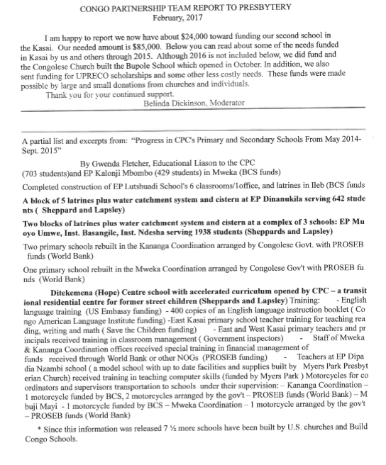

DeVries, Dawn. “Ever to be Reformed According to the Word of God”

